Mål eksamensopgaver:

Kapitel 1
1.8 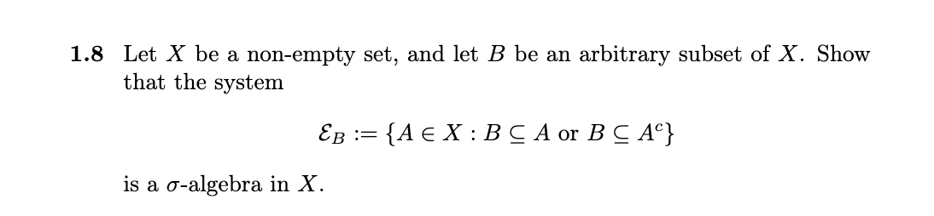
(lille typeo; $A⊆X ikke A∈X$)
$σ1$)$B⊆X per konstruktion da X∈E_{B}$
$σ2$) lad$A⊆X$ da $A∈E_{B}⇔B⊆A eller B⊆A^{C}⇔A^{C}∈E_{B}$
Da ${\left(A^{C}\right)}^{C}=A$
$σ3$) lad ${\left\{A_{n}\right\}}_{n∈N}⊆E_{B}$
Altså $B⊆A_{n} eller B⊆A_{n}^{C} ∀n∈N$
2 cases
$$∃i∈N:B⊆A_{i}$$
$$⇒B⊆A_{i}⊆\bigcup_{n∈N}{A_{n}}⇒\bigcup_{n∈N}{A_{n}}∈E_{B}$$
$$∀i∈N:B⊆A_{i}^{C}$$
Men dette betyder præcis
$$B⊆\bigcap_{n∈N}{A_{i}^{C}}={\left(\bigcup_{n∈N}{A_{n}}\right)}^{C}⇒\bigcup_{n∈N}{A_{n}}∈E_{B}$$
De morgans

1.15
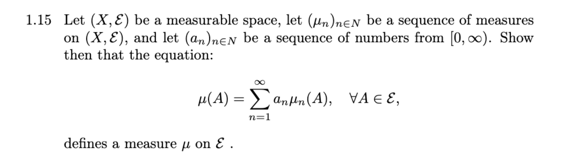
Tjek betinglserne for at være et mål

$m1$) $μ\left(Ø\right)=\lim_{N→∞}{\sum_{n=1}^{N}{a_{n}·μ_{n}(Ø)}}=\lim_{N→∞}{\sum_{n=1}^{N}{0}}=0$
$m2)$ lad ${\left\{A_{j}\right\}}_{j∈N}⊆E$ være disjunkte
$$μ\left(\bigcup_{j∈N}{A_{j}}\right)=\sum_{n=1}^{∞}{a_{n}·μ_{n}(\bigcup_{j∈N}{A_{j}})}$$
Da $μ_{n}$ er mål
$$\sum_{n=1}^{∞}{\sum_{j=1}^{∞}{a_{n}·μ_{n}(A_{j})}}$$
Vi kan altid rykke $a_{n}$ ind (analyse 2)
B.2.15 giver da siden $a_{n}·μ_{n}\left(A_{j}\right)∈\left[0,∞\right) ∀n,j∈N^{2}$
$$⇒\sum_{n=1}^{∞}{\sum_{j=1}^{∞}{a_{n}·μ_{n}(A_{j})}}=\sum_{j=1}^{∞}{\sum_{n=1}^{∞}{a_{n}·μ_{n}(A_{j})}}$$
$$=\sum_{j=1}^{∞}{μ\left(A_{j}\right)}$$
Qed

1.16
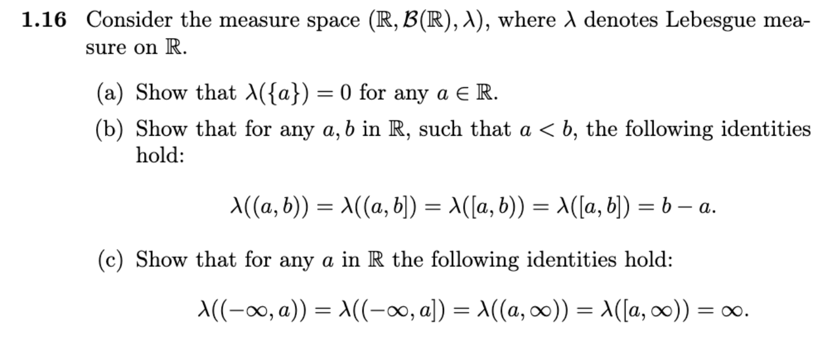
$$λ\left(\left(a,b\right)\right)=b-a for a,b∈R:b>a$$
a)AFM $λ\left(\left\{a\right\}\right)>0$
lad $c<a<b$
$$λ\left(\left(c,b\right)\right)=λ\left(\left(c,a\right)\right)+λ\left(\left\{a\right\}\right)+λ\left(\left(a,b\right)\right)=\left(a-c\right)+λ\left(\left\{a\right\}\right)+\left(b-a\right)=b-c+λ(\left\{a\right\})$$
Men $λ\left(\left(c,b\right)\right)=b-c$
Her bruger vi at de 3 mængder er disjunkte og da $λ$ er et mål må vi dele det op
Da modstrid og $λ\left(\left\{a\right\}\right)=0$

b)
$$λ\left(\left\{a\right\}\right)+λ(\left(a,b\right)=λ(\left(a,b\right))=λ\left(\left(a,b\right)\right)+λ\left(\left\{b\right\}\right)=λ\left(\left\{a\right\}\right)+λ\left(\left(a,b\right)\right)+λ\left(\left\{b\right\}\right)$$
$$⇒λ\left(\left[a,b\right)\right)=λ\left(\left(a,b\right)\right)=λ\left(\left(a,b\right]\right)=λ\left(\left[a,b\right]\right)=b-a$$

c)
vi konstruerer mængder som ”konvergerer” mod de ønskede
$$A_{n}=\left(a-n,a\right)↑\left(-∞,a\right)$$
$$A_{n}^{'}=\left(a-n,a\right]↑\left(-∞,a\right]$$
$$B_{n}=(a,a+n)↑\left(a,∞\right)$$
$$B_{n}^{'}=[a,a+n)↑[a,∞)$$
$$∀n∈N$$
Hvor $A_{n}↑\left(-∞,a\right), A_{n}^{'}↑\left(-∞,a\right], B_{n}↑\left(a,∞\right), B_{n}^{'}↑[a,∞)$
Da siger 1.3.4(v)
$$μ\left(\bigcup_{n∈N}{C_{n}}\right)=\lim_{n→∞}{μ\left(C_{n}\right)}$$

Da
$$μ\left(A_{n}\right)=n=μ\left(A_{n}^{'}\right)=μ\left(B_{n}\right)=μ\left(B_{n}^{'}\right)∀n∈N$$
Skal vi bare tage en grænse
Men den er triviel
$$n→∞ for n→∞….$$
Kapitel 4
4.5 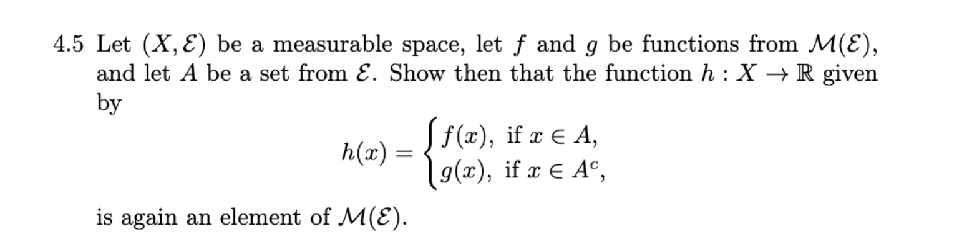
For ikke at skulle bøvle med ”imbedings” bygger vi
$$f^{'}\left(x\right)=f\left(x\right)·I_{A}\left(x\right)$$
$$g^{'}\left(x\right)=g\left(x\right)·I_{A^{C}}(x)$$
Nok at vise $f^{'},g^{'}∈M(E)$

Viser for f
Lad $B∈B(R)$
$${f^{'}}^{-1}\left(B\right)=\left\{x∈X:f\left(x\right)·I_{A}\left(x\right)∈B\right\}$$
$$=\left\{x∈A:f\left(x\right)∈B\right\}∪\{x∈A^{C}:f\left(x\right)·I_{A}\left(x\right)∈B\}$$
$$=\left\{\begin{aligned}\left(A∩f^{-1}\left(B\right)\right)∪A^{C} hvis 0∈B \\ A∩f^{-1}\left(B\right) ellers\end{aligned}\right.$$
Men da $A,A^{C},f^{-1}\left(B\right)∈E⇒{f^{'}}^{-1}\left(B\right)∈E$
Og da $f'∈M(E)$
Analogt for $g'$

Da $f^{'},g^{'}∈M(E)$ og siden $M(E)$ er et vektorrum har vi

$$⇒f^{'}+g^{'}=h∈M(E)$$

4.10
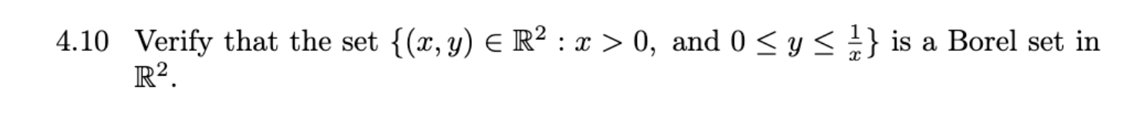
Sæt $f\left(x\right)=\left\{\begin{aligned}\frac{1}{x} x∈(0,∞) \\ 0 ellers\end{aligned}\right.$ denne er klart målelig da $\frac{1}{x}$ er kontinuert på $(0,∞)$
Da per tuborg reglen
Vi skal også bruge at projektioner er kontinuerte og derved målelige

Lad os se om vi ikke kan skrive det som et snit af borelmængder
$$\left\{\left(x,y\right)∈R^{2}:x>0,0≤y≤\frac{1}{x}\right\}$$
$$=\left\{\left(x,y\right)∈R^{2}:x>0,y=0\right\}∪\left\{\left(x,y\right)∈R^{2}:0<y≤\frac{1}{x}\right\}$$
$$=\left(\left\{\left(x,y\right)∈R^{2}:x>0\right\}∩\left\{\left(x,y\right)∈R^{2}:y=0\right\}\right)∪\left\{\left(x,y\right)∈R^{2}:0<y≤\frac{1}{x}\right\}$$
$$=\left(p_{1}^{-1}\left(\left(0,∞\right)\right)∩p_{2}^{-1}\left(\left\{0\right\}\right)\right)∪\left\{\left(x,y\right)∈R^{2}:0<y≤\frac{1}{x}\right\}$$
Venstre side er klart borel da projektioner er målelige
$$⇒\left(p_{1}^{-1}\left(\left(0,∞\right)\right)∩p_{2}^{-1}\left(\left\{0\right\}\right)\right)∈B(R^{2})$$
$$\left\{\left(x,y\right)∈R^{2}:0<y≤\frac{1}{x}\right\}=\left\{\left(x,y\right)∈R^{2}:0<y≤f(x)\right\}$$
$$\left\{\left(x,y\right)∈R^{2}:0<y\right\}∩\left\{\left(x,y\right)∈R^{2}:0≤f\left(x\right)-y\right\}$$
$$=p_{2}^{-1}\left(\left(0,∞\right)\right)∩{\left(f∘p_{1}-p_{2}\right)}^{-1}(\left(0,∞\right))$$
Da $p_{1},f,p_{2}$ er målelige er sammensætning og ”-” også målelig
Da $p_{2}^{-1}\left(\left(0,∞\right)\right)∩{\left(f∘p_{1}-p_{2}\right)}^{-1}\left(\left(0,∞\right)\right)∈B(R^{2})$
Og fra før har vi da
$$\left\{\left(x,y\right)∈R^{2}:x>0,0≤y≤\frac{1}{x}\right\}∈B(R^{2})$$

Kapitel 5
5.2
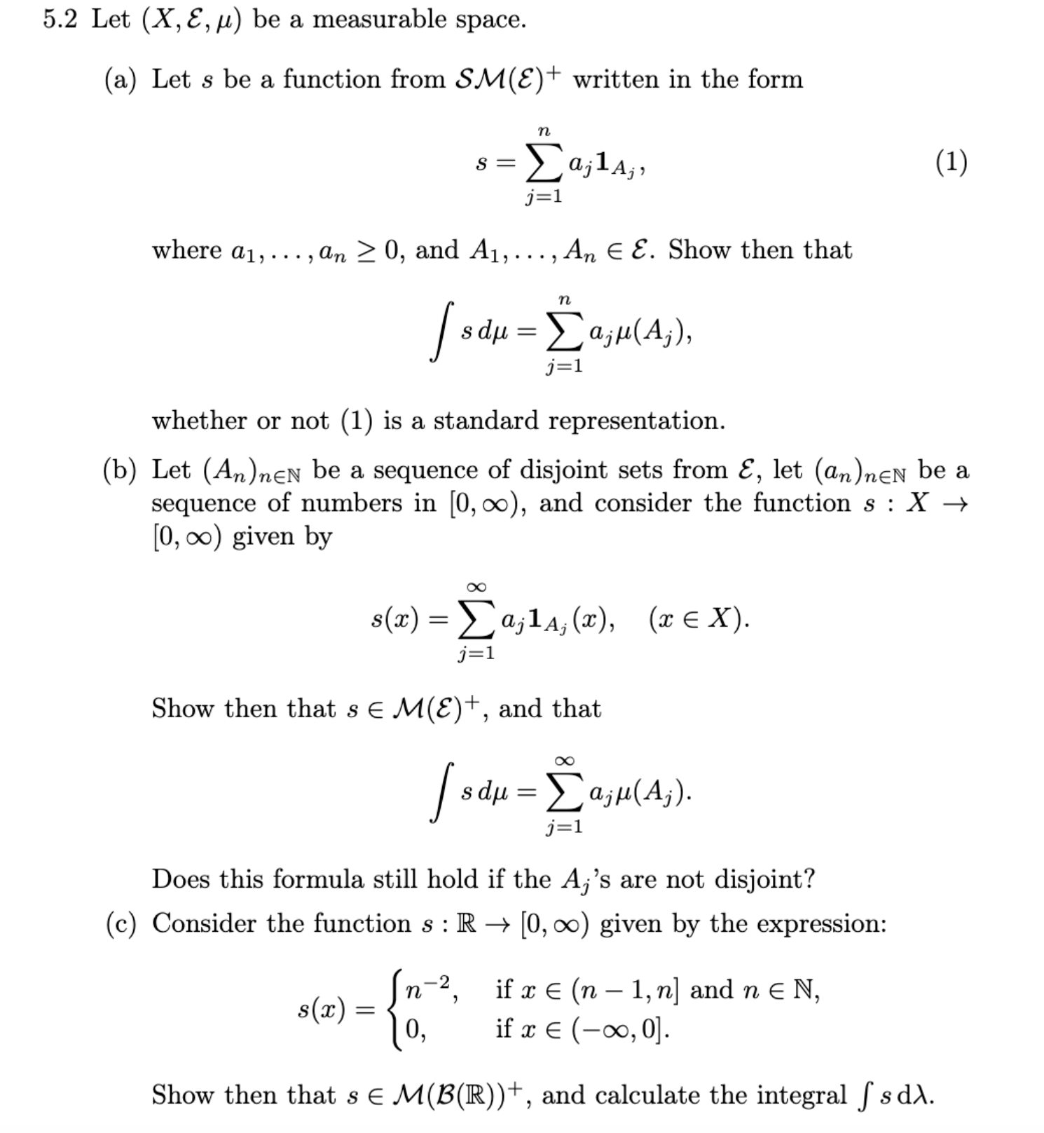
- 5.2.7(ii+iii) giver da $a_{j}I_{A_{j}}∈SM{\left(E\right)}^{+}⊆M{\left(E\right)}^{+}$
$$\int{s dμ}=\int{\sum_{j=1}^{n}{a_{j}I_{A_{j}}}dμ}=\sum_{j=1}^{n}{\int{a_{j}I_{A_{j}}dμ}}=\sum_{j=1}^{n}{a_{j}·μ(A_{j})}$$
- Lad ${\left\{A_{n}\right\}}_{n∈N}⊆E,A_{n}-disjunkte$ lad ${\left\{a_{n}\right\}}_{n∈N}$
Lad $s_{n}=\sum_{j=1}^{n}{a_{j}I_{A_{j}}}∈SM{\left(E\right)}^{+}⊆M{\left(E\right)}^{+}∀n∈N$

Lad $x∈R$
Da er $s_{n}\left(x\right)≤s_{n+1}\left(x\right),$
Hvis $∃i∈N:x∈A_{i}$
$$s_{n}\left(x\right)≤a_{i}$$
Ellers
$$s_{n}\left(x\right)≤0$$
Udanset har vi punktvis konvergens da vi for alle x har en monoton og begrænset følge
Vi ser da $s_{n}↑s for n→∞∀x∈R$

Da giver 4.3.7
$$s∈M\left(E\right)$$

Formula:
Monoton konvergens
Da $s_{n}↑s$ har vi per (a)
$$\int{s}dμ=\lim_{n→∞}{\int{s_{n}dμ}}=\lim_{N→∞}{\sum_{i=1}^{N}{a_{j}μ\left(A_{j}\right)}}$$
$$=\sum_{i=1}^{∞}{a_{j}μ\left(A_{j}\right)}$$

5.7
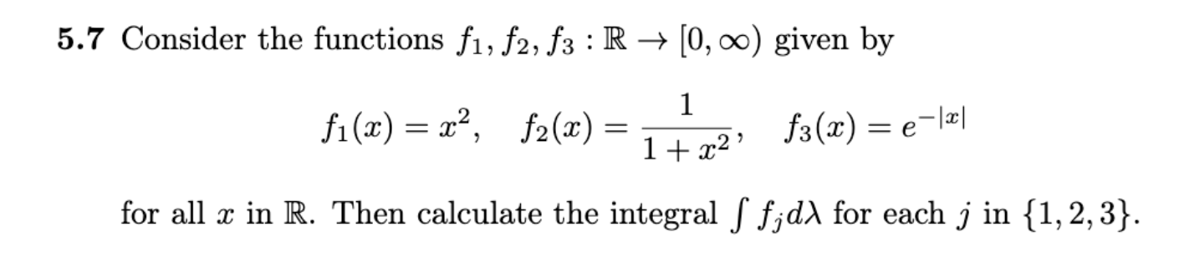
Bemærk $f_{j}≥0 og er kontinuerte ∀j∈\{1,2,3\}$
$⇒f_{j}∈\overline{M}{\left(E\right)}^{+}$
Da konstruere vi
$$f_{j}^{n}=f_{j}·I_{\left[-n,n\right]}$$
Hvor
$$f_{j}^{n}↑f_{j} for n→∞∀j∈\{1,2,3\}$$
Da giver monoton konvergens
$$\int{f_{j}dλ}=\lim_{n→∞}{\int{f_{j}^{n}dλ}}=\lim_{n→∞}{R\int_{-n}^{n}{f_{j}\left(x\right)λ\left(dx\right)}}$$

Da regner vi
$$\int{f_{1}dλ}=\lim_{n→∞}{R\int_{-n}^{n}{x^{2}λ\left(dx\right)}}$$
$$R\int_{-n}^{n}{x^{2}λ\left(dx\right)}={\left[\frac{1}{3}x^{3}\right]}_{-n}^{n}=\frac{1}{3}n^{3}-\frac{1}{3}{\left(-n\right)}^{3}=\frac{2}{3}n^{3}→∞ for n→∞$$

$$\int{f_{2}dλ}$$
Bemærk
$$\frac{f_{2}}{π} er densiteten for cauchy fordelingen$$
Da
$$\int{f_{2}dμ}=\int{\frac{πf_{2}}{π} dλ}=\int{π d(μ·\frac{f_{2}}{π})}=π·\int{1 d(μ·\frac{f_{2}}{π})}=π$$

$$\int{f_{3}dλ}=\lim_{n→∞}{R\int_{-n}^{n}{e^{-\left|x\right|}}}$$
$$R\int_{-n}^{n}{e^{-\left|x\right|}}=2·R\int_{0}^{n}{e^{-x}}=2·{\left[-e^{-x}\right]}_{0}^{n}=2·\left(1-e^{-n}\right)→2 for n→∞$$

5.12
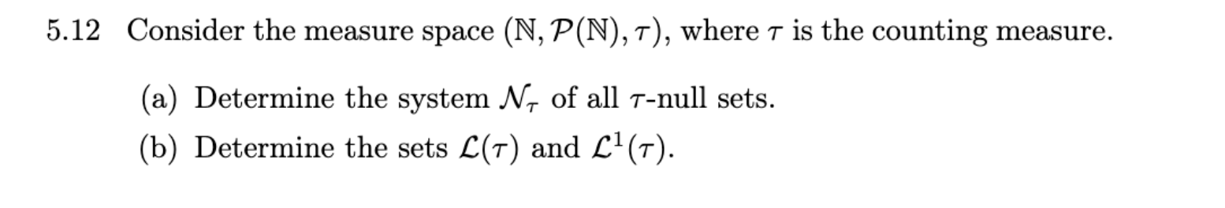
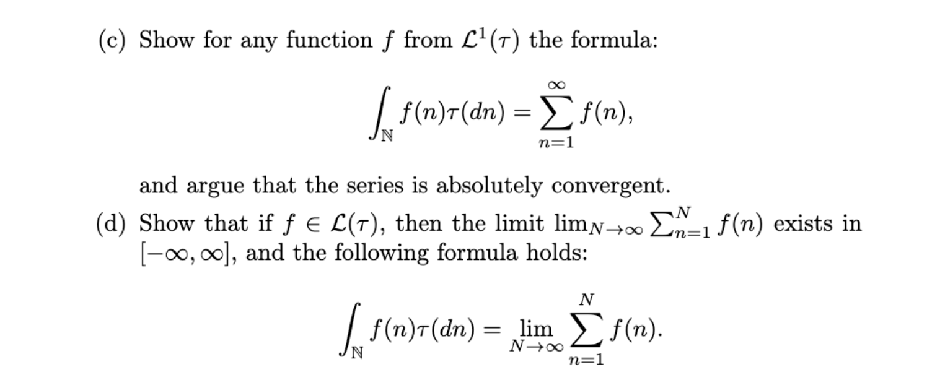
- $N∈N_{τ}⇔∃A∈P\left(N\right):N⊆A,τ\left(A\right)=0$
Men $τ\left(A\right)=0⇔A=Ø$
Da vi snakker om tællemålet
$$⇒N∈N_{τ}⇔N=Ø$$
- Alle funktioner er målelige da vores sigma-algebra er $"P(N)"$ dette har vi vist i opgave 4.4
Eksempel 5.2.13 giver integralet
$$∀f:N→\left[0,∞\right]:\int{fdτ}=\sum_{n=1}^{∞}{f(n)}$$
Da $f^{+},f^{-}$ er positive rækker giver det os beskrivelsrne

$$L\left(τ\right)=\left\{f:N→\left[0,∞\right] | \sum_{n=1}^{∞}{f^{+}\left(n\right)}∧\sum_{n=1}^{∞}{f^{-}\left(n\right)}<∞\right\}$$
$$\left\{f:N→\left[0,∞\right] | den positive eller negative del konvergerer\right\}$$

$$L^{1}\left(τ\right)=\left\{f:N→\left[0,∞\right] | \sum_{n=1}^{∞}{f^{+}\left(n\right)}∨\sum_{n=1}^{∞}{f^{-}\left(n\right)}<∞\right\}$$
$$=\left\{f:N→\left[0,∞\right] | både positive og negative del konvergerer \right\}$$

- Lad $f∈L^{1}(τ)$ definitionen af integralet og 5.4.6(linaritet af integralet) giver da
$$\int_{N}{fdτ}=\int_{N}{f^{+}-f^{-}dτ}=\int_{N}{f^{+}dτ}-\int_{N}{f^{-}dτ}=\sum_{n∈N}{f^{+}(n)}-\sum_{n∈N}{f^{-}(n)}$$
$$=\lim_{M→∞}{\sum_{n=1}^{M}{f^{+}(n)}}-\lim_{M→∞}{\sum_{n=1}^{M}{f^{-}(n)}}$$
Da begge konvergerer
$$=\lim_{M→∞}{\sum_{n=1}^{M}{f^{+}(n)}-\sum_{n=1}^{M}{f^{-}(n)}}=\lim_{M→∞}{\sum_{n=1}^{M}{f^{+}\left(n\right)-f^{-}(n)}}=\sum_{n∈N}{f(n)}$$
Da $\left|f\left(n\right)\right|∈L^{1}(τ)$
$$\sum_{n∈N}{\left|f\left(n\right)\right|}=\int{\left|f\right|dτ}=\int{f^{-}+f^{+}dτ}=\int{f^{+}dτ}+\int{f^{-}dτ}=\sum_{n=1}^{∞}{f^{+}\left(n\right)}+\sum_{n=1}^{∞}{f^{-}\left(n\right)}$$
$$≤2·\left(\sum_{n=1}^{∞}{f^{+}\left(n\right)}∨\sum_{n=1}^{∞}{f^{-}\left(n\right)}\right)<∞$$
Da er ”serien” $s_{N}=\sum_{n∈\{1,…,N\}}{\left|f\left(n\right)\right|}$ absolut konvergent
- Lad $f∈L\left(τ\right)∖L^{1}(τ)$ da vi allerede har vist at formlen holder i tilfældet $f∈L^{1}(τ)$ i (c)
Antag UTAG $\sum_{n=1}^{∞}{f^{+}\left(n\right)}=∞$
$$f∈L\left(τ\right)⇒\int_{N}{fdτ}=\int_{N}{f^{+}dτ}-\int_{N}{f^{-}dτ}=\sum_{n=1}^{∞}{f^{+}\left(n\right)}-\sum_{n=1}^{∞}{f^{-}\left(n\right)}=∞-c=∞$$
$$=\sum_{n∈N}{f(n)}$$
Og vi er færdige

5.14
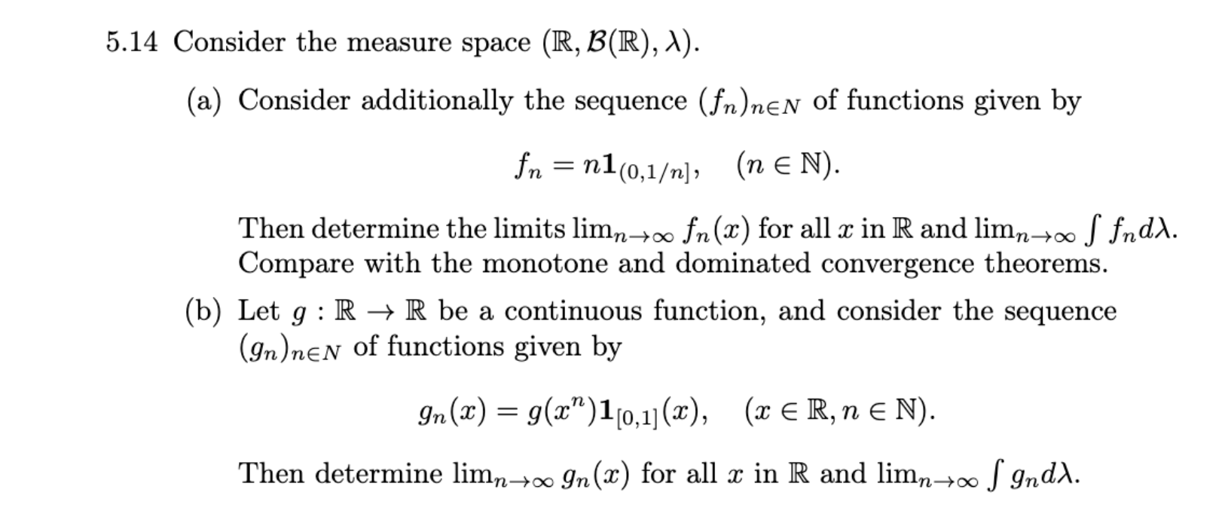
- $f_{n}→0 for n→0$
Punktvis
Tjek:
$$x∈\left(-∞,0\right]∪(1,∞)$$
$$⇒f_{n}\left(x\right)=0∀n∈N$$
$$x∈\left(0,1\right]$$
$$∃N∈N:\frac{1}{N}<x⇒f_{n}\left(x\right)=0∀n≥N$$
$$\lim_{n→∞}{f_{n}\left(x\right)}=0$$
$$\int{0dλ}=0$$
$$\int{f_{n}dλ}=n·\frac{1}{n}=1∀n∈N$$
$$\lim_{n→∞}{\int{f_{n}dλ}}=1$$

Begge skal være forkerte da $1≠0$
Monoton konvergens?
Betingelse:
$$f_{n}↑f$$
Ikke opfyldt

Domineret konvergens
$$∃g∈M{\left(E\right)}^{+}:\left|f_{n}\right|≤g∀n∈N,\int{gdλ}<∞$$
Så hvad skal g opfylde
$$g≥\left|f_{n}\right|$$
Dan en ”hjælpefunktion” s som f’s upper bound
$$s\left(x\right)=\sum_{i=1}^{∞}{n·I_{\left(\frac{1}{n+1},\frac{1}{n}\right]}}(x)$$
Opgave 5.2(b) giver da
$$\int{s dμ}=\sum_{i=1}^{∞}{n·λ\left(\left(\frac{1}{n+1},\frac{1}{n}\right)\right)}$$
$$=\sum_{n=1}^{∞}{n·\left(\frac{1}{n}-\frac{1}{n+1}\right)}=\sum_{n=1}^{∞}{1-\frac{n}{n+1}}=\sum_{n=1}^{∞}{\frac{1}{n+1}}=∞$$
Og da $g≥s⇒\int{gdλ}≥\int{sdλ}$

$$→\int{gdλ}=∞$$

- $g_{n}\left(x\right)=g\left(x^{n}\right)·I_{\left[0,1\right]}(x)$
Bestem $\lim_{n→∞}{g_{n}(x)}$ $∀x∈R$
$$x∈\left(-∞,0\right)∪\left(1,∞\right)$$
$$⇒g_{n}\left(x\right)=0∀n∈N$$
$$x=1$$
$$\lim_{n→∞}{g_{n}(1)}=g(1)$$
$$x∈[0,1)$$
$$\lim_{n→∞}{g_{n}(x)}=g(\lim_{n→∞}{x^{n})}=g(0)$$
$$\lim_{n→∞}{g_{n}(x)}=\left\{\begin{aligned}g\left(1\right) x=1 \\ g\left(0\right) x∈[0,1) \\ 0 ellers\end{aligned}\right.$$

$$g er kont på \left[0,1\right]⇒\left|g\right| er kont på [0,1]$$
$$⇒∃C∈R^{+}:C≥g\left(x\right)∀x∈[0,1]$$

Da dominerer funktionen
$$h=C·I_{\left[0,1\right]}$$
$$g_{n} ∀n∈N$$
med
$$\int{hdλ}=C$$
Da har vi per DC
$$\lim_{n→∞}{\int{g_{n}dλ}}=\int{\lim_{n→∞}{g_{n}\left(x\right)}}λ\left(dx\right)$$
$$=g(0)$$

5.15
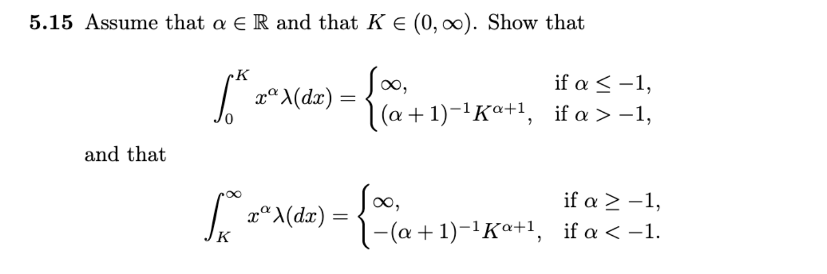

$$\int_{R}{I_{\left(0,K\right]}\left(x\right)·x^{α}λ\left(dx\right)}$$
$$f(x)I_{\left(0,K\right]}\left(x\right)·x^{α}≥0∀x∈R$$
Da definerer vi
$$f_{n}\left(x\right)=I_{\left[\frac{1}{n},K\right]}\left(x\right)·I_{\left(0,K\right]}\left(x\right)·x^{α}$$
Her bruger vi konventionen $\left[\frac{1}{n},K\right]=Ø$ hvis $\frac{1}{n}>K$
Da $f_{n}↑f ∀x∈R$
Siger monoton konvergens
$$\int_{R}{f\left(x\right)λ\left(dx\right)}=\lim_{n→∞}{\int{f_{n}\left(x\right)λ\left(dx\right)}}$$

Vi behøver kun kigge på halen da
$$∃N∈N:n≥N$$
$$⇒\int{f_{n}\left(x\right)λ\left(dx\right)}=\int_{R}{I_{\left[\frac{1}{n},K\right]}\left(x\right)·I_{\left(0,K\right]}\left(x\right)·x^{α}}$$
$$=\int_{R}{I_{\left[\frac{1}{n},K\right]}\left(x\right)·x^{α}}=R\int_{\frac{1}{n}}^{K}{x^{α}dx}$$
3 cases $α=-1$:
$$R\int_{\frac{1}{n}}^{K}{x^{α}dx}={\left[\log\left(x\right)\right]}_{\frac{1}{n}}^{K}=\log\left(K\right)-\log\left(\frac{1}{n}\right)=\log\left(K\right)+\log\left(n\right)→∞ for n→∞$$

$α>-1$:
$$R\int_{\frac{1}{n}}^{K}{x^{α}dx}={\left[\frac{x^{α+1}}{α+1}\right]}_{\frac{1}{n}}^{K}=\frac{1}{α+1}·\left(K^{α+1}-{\left(\frac{1}{n}\right)}^{α+1}\right)$$
Vi ser ${\left(\frac{1}{n}\right)}^{α+1}→0 for n→∞$ da $α+1>0$

$α<-1$: samme udregninger

$$R\int_{\frac{1}{n}}^{K}{x^{α}dx}=\frac{1}{α+1}·\left(K^{α+1}-{\left(\frac{1}{n}\right)}^{α+1}\right)$$
$${\left(\frac{1}{n}\right)}^{α+1}→∞ for n→∞$$
Da
$$\frac{1}{α+1}·\left(K^{α+1}-{\left(\frac{1}{n}\right)}^{α+1}\right)→∞$$
Da $\frac{1}{α+1}<0$

$$\int_{R}{I_{[K,∞)}\left(x\right)·x^{α}λ\left(dx\right)}$$
Præcis samme approach
$$f\left(x\right)=I_{[K,∞)}\left(x\right)·x^{α}$$
$$f_{n}(x)=I_{[K,n)}\left(x\right)·x^{α}$$
$$f_{n}↑f$$
Pr monoton konvergens
$$\int_{R}{f\left(x\right)λ\left(dx\right)}=\lim_{n→∞}{\int{f_{n}\left(x\right)λ\left(dx\right)}}$$
Igen behøver vi kun kigge på halen for $n>K$

$$\int{f_{n}\left(x\right)λ\left(dx\right)}=R\int_{K}^{n}{x^{α}dx}$$
$α=-1$:

$$R\int_{K}^{n}{x^{α}dx}={\left[\log\left(x\right)\right]}_{K}^{n}=\log\left(n\right)-\log\left(K\right)→∞ for n→∞$$

$α<-1$:
$$\int_{K}^{n}{x^{α}dx}={\left[\frac{x^{α+1}}{α+1}\right]}_{K}^{n}=\frac{1}{α+1}(n^{α+1}-K^{α+1})$$
$$α<-1⇒α+1<0⇒(n^{α+1}→0 for n→∞)$$
da
$$\frac{1}{α+1}\left(n^{α+1}-K^{α+1}\right)→-\frac{1}{α+1}·K^{α+1} for n→∞$$

$α>-1$:
$$\int_{K}^{n}{x^{α}dx}={\left[\frac{x^{α+1}}{α+1}\right]}_{K}^{n}=\frac{1}{α+1}\left(n^{α+1}-K^{α+1}\right)$$
$$α>-1⇒α+1>0⇒(n^{α+1}→∞ for n→∞)$$
$$⇒\frac{1}{α+1}\left(n^{α+1}-K^{α+1}\right)→∞ for n→∞$$

Kapitel 6

6.4
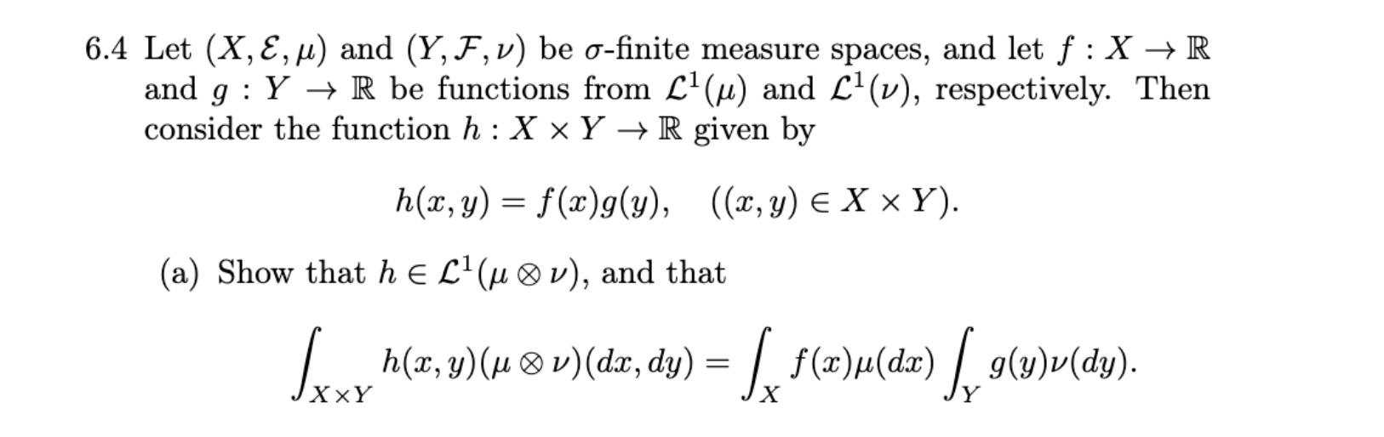
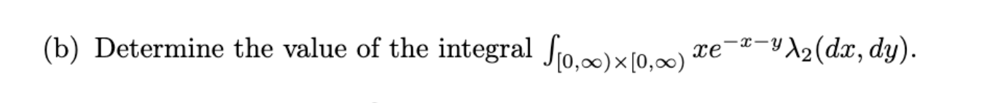

a)
projektioner er målelige, hhv g,f er målelige da er $f∘p_{1},g∘p_{2}∈\overline{M}(E⊗F),$ og derved $\left|f∘p_{1}·g∘p_{2}\right|∈\overline{M}{\left(E⊗F\right)}^{+}$

$$p_{1},p_{2} er hhv E⊗F-E,F målelige$$
Da kan vi bruge tonelli
$$\int_{X×Y}{\left|H\right|\left(x,y\right)}\left(μ⊗ν\right)\left(dx,dy\right)=\int_{X}{\left(\int_{Y}{\left|f\left(x\right)\right|·\left|g\left(y\right)\right|ν\left(dy\right)}\right)μ(dx)}$$
$$=\int_{X}{\left(\left|f\left(x\right)\right|\int_{Y}{\left|g\left(y\right)\right|ν\left(dy\right)}\right)μ(dx)}=\int_{X}{\left(\left|f\left(x\right)\right|C\right)μ(dx)}=C·K<∞$$
Hvor c,k er integralerne for hhv $\left|f\right|,\left|g\right|$
Og derved $h∈L^{1}(μ⊗ν)$
Vi skal nu til at bruge fubini ve bemærker dog først at $∀x∈X$
$$\int_{Y}{\left|h\left(x,y\right)\right|λ(dy)}=\left|f(x)\right|\int_{Y}{\left|g(y)\right|λ(dy)}=\left|f(x)\right|k<∞$$
Da $f∈M(E)$
Derved $N=\left\{x∈X:\int_{Y}{\left|h\left(x,y\right)\right|λ\left(dy\right)}=∞\right\}=Ø$
Da giver fubini det ønskede resultat
$$\int_{X×Y}{h\left(x,y\right)}\left(μ⊗ν\right)\left(dx,dy\right)=\int_{X}{\left(\int_{Y}{f(x)·g(y)ν\left(dy\right)}\right)μ(dx)}$$
$$=\int_{X}{f(x)\left(\int_{Y}{g(y)ν\left(dy\right)}\right)μ(dx)}=\int_{Y}{g(y)ν\left(dy\right)}\int_{X}{f(x)μ(dx)}$$
Qed

b)
per (a)
$$\int_{R^{2}}{I_{\left[0,∞\right)}\left(x\right)·I_{\left[0,∞\right)}\left(y\right)·x·e^{-x}·e^{-y}λ_{2}\left(dx,dy\right)}$$
$$=\int_{R}{I_{\left[0,∞\right)}\left(x\right)·}x·e^{-x}λ\left(dx\right)·\int_{R}{I_{\left[0,∞\right)}\left(y\right)e^{-y}}$$
Begge integraler regnes ved monoton konvergens
1.
$$I_{\left[0,n\right]}\left(x\right)·x·e^{-x}↑I_{\left[0,∞\right)}\left(x\right)·x·e^{-x}$$
Da giver kntinuitet
$$\int_{R}{I_{\left[0,∞\right)}\left(x\right)·}x·e^{-x}λ\left(dx\right)=\lim_{n→∞}{R\int_{0}^{n}{x·e^{-x}}}$$
Partiel integration
$$u=x,v^{'}=e^{-x}$$
$$⇒u^{'}=1,v=-e^{-x}$$
$$\int_{0}^{n}{x·e^{-x}}={\left[-x·e^{-x}\right]}_{0}^{n}+\int_{0}^{n}{e^{-x}}=-n·e^{-n}+0+{\left[-e^{-x}\right]}_{0}^{n}=-n·e^{-n}-e^{-n}+1$$
$$-n·e^{-n}-e^{-n}+1→1 for n→∞$$

2.
Samme strategi
$$I_{\left[0,n\right]}\left(y\right)·e^{-y}↑I_{\left[0,∞\right)}\left(y\right)e^{-y}$$

$$\int_{R}{I_{\left[0,∞\right)}\left(y\right)e^{-y}λ(dy)}=\lim_{n→∞}{R\int_{0}^{n}{e^{-y}λ(dy)}}=\lim_{n→∞}{-e^{n}+1}=1$$
Derved
$$\int_{R}{I_{\left[0,∞\right)}\left(x\right)·}x·e^{-x}λ\left(dx\right)·\int_{R}{I_{\left[0,∞\right)}\left(y\right)e^{-y}}=1$$
6.5
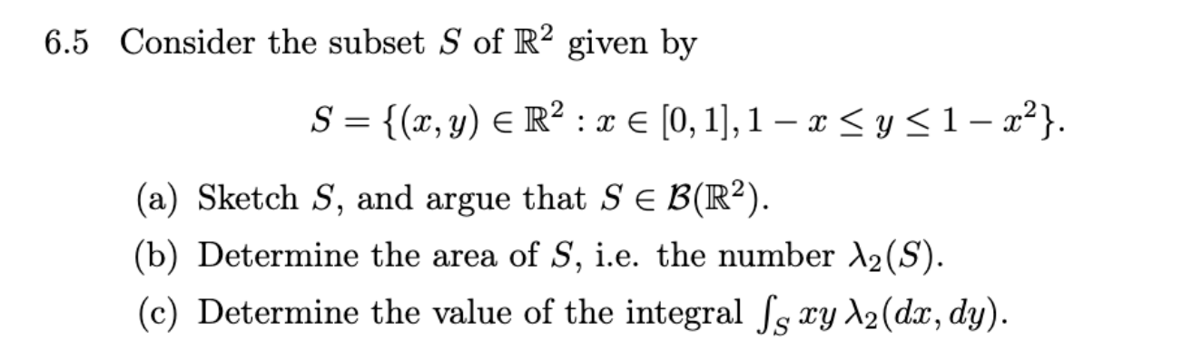
a)
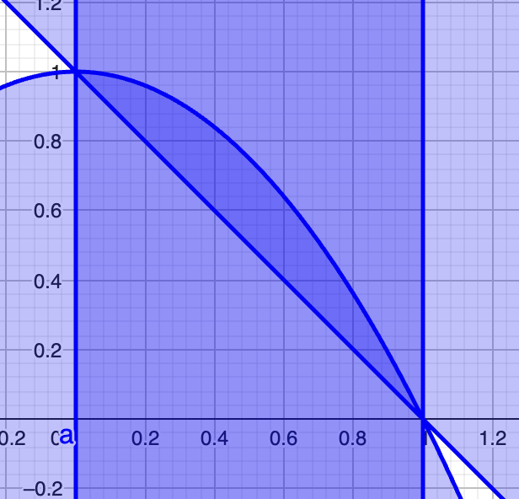
Projections are continous thus measureable
thus everything is measureable
$$1-p_{1}\left(x,y\right)-p_{2}\left(x,y\right)$$
$$p_{2}-1+p_{2}^{2}$$
Especially
$$S=p_{1}^{-1}\left(\left[0,1\right]\right)∩{\left(1-p_{1}-p_{2}\right)}^{-1}\left(\left(-∞,0\right]\right)∩{\left(p_{2}-1+p_{2}^{2}\right)}^{-1}\left(\left(-∞,0\right]\right)$$
Alle er individuelt borelmængder da $S∈B\left(R^{2}\right)$

b)
$λ_{2}$ er præcis produktmålet af lebesgue mål per 6.3.3 har vi
$$λ_{2}\left(S\right)=\int_{R}{λ\left(S_{X}\right)λ\left(dx\right)}$$
$$λ\left(S_{x}\right)=I_{\left[0,1\right]}\left(x\right)·\left(1-x^{2}-\left(1-x\right)\right)=I_{\left[0,1\right]}\left(x\right)·\left(x-x^{2}\right)$$
$x-x^{2}$ er kontinuert og derved integrabel på $[0,1]$ da er lebesgue integralet lig riemann
$$\int_{R}{I_{\left[0,1\right]}\left(x\right)·\left(x-x^{2}\right)λ\left(dx\right)}$$
$$=R\int_{0}^{1}{x-x^{2}dx}={\left[\frac{1}{2}x^{2}-\frac{1}{3}x^{3}\right]}_{0}^{1}=\frac{1}{2}-\frac{1}{3}=\frac{1}{6}$$

c)
$$\int_{R^{2}}{I_{S}\left(x,y\right)·x·y}λ_{2}\left(dx,dy\right)$$

bemærk $I_{S}\left(x,y\right)·x·y≥0 ∀\left(x,y\right)∈R^{2}$
$p_{1}·p_{2}$ er målelig
Da $S∈B(R^{2})$har vi per opgave 4.5
$$I_{S}\left(x,y\right)·x·y∈M{\left(B\left(R^{2}\right)\right)}^{+}$$
Tonelli’s giver da
$$\int_{R^{2}}{I_{S}\left(x,y\right)·x·y}λ_{2}\left(dx,dy\right)=\int_{R}{\left(\int_{R}{I_{S}\left(x,y\right)·x·y λ\left(dy\right)}\right)λ(dx)}$$
$$I_{S}\left(x,y\right)=I_{\left[0,1\right]}\left(x\right)·I_{\left[1-x,1-x^{2}\right]}(y)$$
$$\int_{R}{\left(\int_{R}{I_{\left[0,1\right]}\left(x\right)·I_{\left[1-x,1-x^{2}\right]}(y)·x·y λ\left(dy\right)}\right)λ(dx)}$$
$$=\int_{R}{\left(I_{\left[0,1\right]}\left(x\right)·x\int_{R}{·I_{\left[1-x,1-x^{2}\right]}(y)·y λ\left(dy\right)}\right)λ(dx)}$$
$$\int_{R}{I_{\left[1-x,1-x^{2}\right]}\left(y\right)·y λ\left(dy\right)}=R\int_{1-x}^{1-x^{2}}{y}dy={\left[\frac{y^{2}}{2}\right]}_{1-x}^{1-x^{2}}=\frac{1}{2}·\left({\left(1-x^{2}\right)}^{2}-{\left(1-x\right)}^{2}\right)$$
$$=\frac{1}{2}·\left(1-2x^{2}+x^{4}\right)-\frac{1}{2}·\left(1-2x+x^{2}\right)$$
$$=\frac{1}{2}(2x-3x^{2}+x^{4})$$
$$\int_{R}{\left(I_{\left[0,1\right]}\left(x\right)·x\frac{1}{2}(-2x-3x^{2}+x^{4})\right)λ(dx)}$$
$$=R\int_{0}^{1}{\frac{1}{2}(-2x^{2}-x^{3}+x^{5})}$$
$$=\frac{1}{2}·{\left[\frac{2}{3}x^{3}-\frac{3}{4}x^{4}+\frac{1}{6}x^{6}\right]}_{0}^{1}=\frac{1}{2}·\left(\frac{2}{3}-\frac{3}{4}+\frac{1}{6}\right)=\frac{1}{2}·\left(\frac{5}{6}-\frac{3}{4}\right)=\frac{1}{2}·\frac{1}{12}=\frac{1}{24}$$

6.7
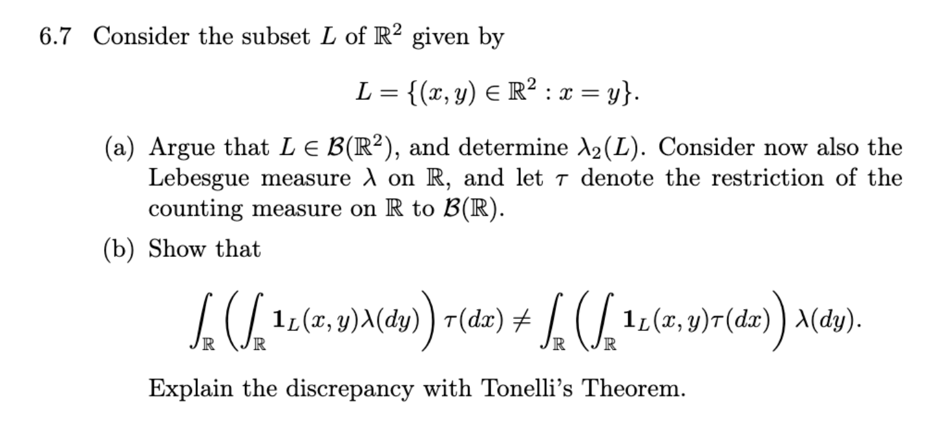
- $L=\left\{\left(x,y\right)∈R:x=y\right\}=\left\{\left(x,y\right)∈R^{2}:x-y≥0\right\}∩\left\{\left(x,y\right)∈R^{2}:-x+y≥0\right\}$
Det er 2 lukkede mængder
Da $B(R^{2})$ er genereret af mængden af lukkede mængder er $L∈B(R^{2})$
$$λ_{2}\left(L\right)=\int_{R}{λ\left(L_{x}\right)}λ(dx)$$
$$λ\left(L_{x}\right)=λ\left(\left\{x\right\}\right)=0$$
$$\int_{R}{λ\left(L_{x}\right)}λ\left(dx\right)=0$$

- $τ$ er tælle målet
$$\int_{R}{\left(\int_{R}{I_{L}\left(x,y\right)λ\left(dy\right)}\right) τ(dx)}$$
$$\int_{R}{I_{L}\left(x,y\right)λ\left(dy\right)}=λ\left(L_{x}\right)=0$$
$$⇒\int_{R}{\left(0\right) τ(dx)}=0$$

$$\int_{R}{\left(\int_{R}{I_{L}\left(x,y\right) τ\left(dx\right)}\right) λ(dy)}$$
$$\int_{R}{I_{L}\left(x,y\right) τ\left(dx\right)}=τ\left(L_{y}\right)=τ\left(\left\{y\right\}\right)=1$$
$$⇒\int_{R}{1 λ(dy)}=∞$$
Ikke lighed da brud på tonelli,
Betingelsen om at begge mål skal være $σ-endelige$ er ikke opfyldt

$(R,B\left(R\right),τ)$ er ikke sigma - endelig
Afm $τ$ er $σ-finite$
$$∃{\left\{A_{n}\right\}}_{n∈N}⊆B\left(R\right):$$
$$τ\left(A_{n}\right)<∞∀n∈N$$
$$\bigcup_{n∈N}{A_{n}}=R$$
Men da er $A_{n}$ specielt tællelig
Og en tællelig forening af tællelige mængder er tællelig, da må $R$ være tællelig og vi har derved modstrid

6.8
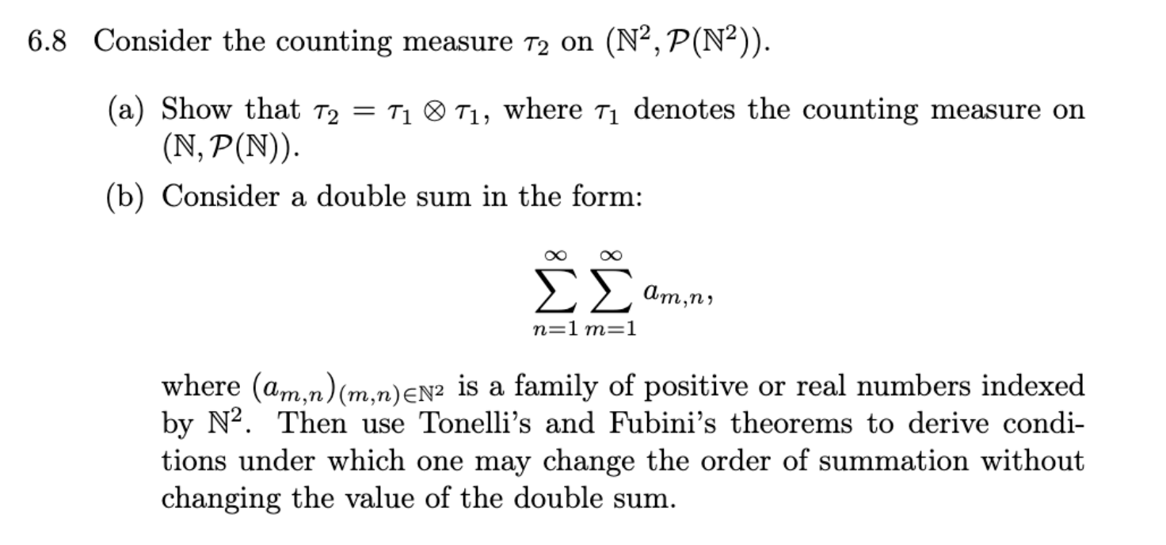

- vis $τ_{2}=τ_{1}⊗τ_{1}$
hvor$τ_{1}⊗τ_{1}$ er det unikke mål som opfylder $τ_{1}⊗τ_{1}=τ_{1}\left(A\right)·τ_{1}\left(B\right)∀A∈P\left(N\right),B∈P(N)$
først skal vi tjekke at de har den samme sigma algebra som domæne
altså vis:
$$P\left(N^{2}\right)=P\left(N\right)⊗P(N)$$
hvor $P\left(N\right)⊗P\left(N\right)=σ(\left\{A×B:A,B∈P\left(N\right)\right\})$
”$⊇$”
$$A,B∈P\left(N\right)⇒A,B⊆N⇒A×B⊆N^{2}⇒A×B∈P(N^{2})$$
Da har vi
$$P\left(N^{2}\right)⊇\{A×B:A,B∈P\left(N\right)\}$$
Da $P\left(N^{2}\right)$ er en sigma algebra er vi færdige
$$⇒P\left(N^{2}\right)⊇σ\left(\left\{A×B:A,B∈P\left(N\right)\right\}\right)$$
”$⊆$”
Lad $S∈P\left(N^{2}\right)⇒S⊆N^{2}$
Da er S tællelig og kan altså skrives som en tællelig forening af singletons
$$S=\bigcup_{n∈N}{A_{n}}$$
Hvor $A_{n}∈N^{2} ∀n∈N$
men så må $A_{n}=\left\{a_{n}\right\}×\left\{b_{n}\right\}:a_{n},b_{n}∈N$
og derved $A_{n}∈\left\{A×B:A,B∈P\left(N\right)\right\}⊆σ\left(\left\{A×B:A,B∈P\left(N\right)\right\}\right)∀n∈N$
da $P\left(N\right)⊗P\left(N\right)$ er en $σ-algebra$ har vi da også $\bigcup_{n∈N}{A_{n}}=S∈P\left(N\right)⊗P(N)$

now to show $τ_{2}=τ_{1}⊗τ_{1}$
enough to show $τ_{2}\left(A×B\right)=τ_{1}\left(A\right)τ_{1}\left(B\right)∀A,B∈P(N)$

lad den ene være en tom mængde(antag A) da
$$τ_{2}\left(A×B\right)=τ_{2}\left(Ø×B\right)=τ_{2}\left(Ø\right)=0=τ_{1}\left(Ø\right)τ_{1}\left(B\right)=τ_{1}\left(A\right)τ_{1}(B)$$

Antag nu at ingen er $Ø$ og antag nu også at $A=N$(UTAG)
$$τ_{2}\left(A×B\right)=∞=∞·τ\left(B\right)=τ\left(A\right)·τ(B)$$

Antag nu at $A,B∉\{Ø,N\}$
$$A×B=\{\left(a_{n},b_{m}\right):n∈\left\{1,…,τ\left(A\right)\right\},m∈\left\{1,…,τ\left(B\right)\right\}\}$$
Da har vi
$$τ_{2}\left(A×B\right)=τ\left(A\right)·τ(B)$$

b)
de her uendelige summer er integraler over tællemålet (husk opgave 5.12)
alle $f:N^{2}→R$ er målelige
hvornår
$$\sum_{n,m∈N}{a_{m,n}}=\sum_{n}^{∞}{\sum_{m}^{∞}{a_{m,n}}}=\sum_{m}^{∞}{\sum_{n}^{∞}{a_{m,n}}}$$
?

$$\int_{N}{\int_{N}{fτ\left(dm\right)}τ(dn)}=\sum_{n}^{∞}{\sum_{m}^{∞}{a_{m,n}}}$$
Tonelli:
Kræver
$$f∈\overline{M}{\left(τ_{2}\right)}^{+}$$
Enhver funktion er målelig da skal vi blot have
$$f\left(n,m\right)=a_{n,m}≥0∀n,m∈N$$

Fubini:
Hvis
$$\int{\left|f\right|dτ_{2}}=\sum_{n,m∈N^{2}}{\left|a_{m,n}\right|}<∞$$

Da
$$\sum_{n}^{∞}{\sum_{m}^{∞}{a_{m,n}}}=\int_{N}{\int_{N}{fτ\left(dm\right)}τ(dn)}=\int_{N}{\int_{N}{fτ\left(dn\right)}τ(dm)}=\sum_{m}^{∞}{\sum_{n}^{∞}{a_{m,n}}}$$

Og vi er færdige
Ingen null sæt btw

Kapitel 7
7.5
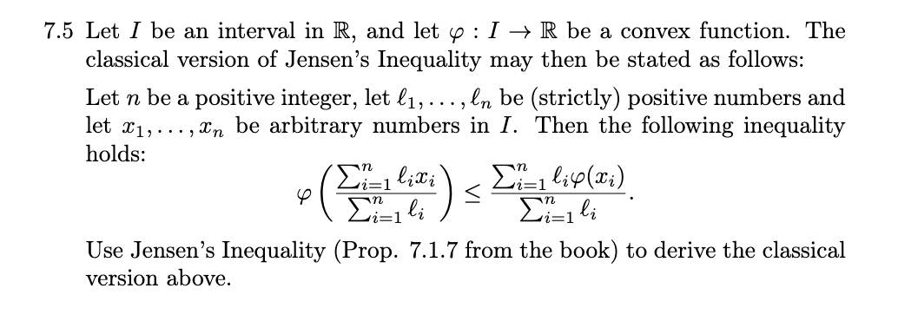
Lad $X=\left\{1,…,n\right\}$
Definer målet per øvelse
$$μ=\sum_{i=1}^{n}{\frac{l_{j}}{α}·δ_{\left\{i\right\}}}$$
Hvor $α=\sum_{i=1}^{n}{l_{i}}$
Da har vi målrummet
$$(X,P\left(X\right),μ)$$
Og bemærker at det er et sandsynlighedsrum da
$$μ\left(X\right)=\sum_{i=1}^{n}{\frac{l_{j}}{α}·δ_{\left\{i\right\}}(X)}=\sum_{i=1}^{n}{\frac{l_{j}}{α}}=1$$
da definerer vi funktionen
$$f:X→I⊆R$$
$$f\left(n\right)=x_{n}$$
F er målelig da vores sigma algebra er potensmængden
F er også i $L^{1}(μ)$
Da $\left|f\right|≤\max_{i∈\{1,…,n\}}\left|x_{i}\right|$ og da vi arbejder i et sansynlighedsrum
$$\int_{X}{\max_{i∈\{1,…,n\}}\left|x_{i}\right|dμ}=\max_{i∈\{1,…,n\}}\left|x_{i}\right|$$
Altså $f∈L^{1}(μ)$

Bemærk også $\left\{f∈I\right\}=X⇒μ\left(\left\{f∈I\right\}\right)=1$
Da bruger vi jensens ulighed
$$ψ\left(\frac{\sum_{i=1}^{n}{l_{i}x_{i}}}{α}\right)=ψ\left(\int_{X}{fdμ}\right)≤\int_{X}{ψ∘fdμ}=\frac{\sum_{i=1}^{n}{l_{i}ψ(x_{i})}}{α}$$

Qed

7.6
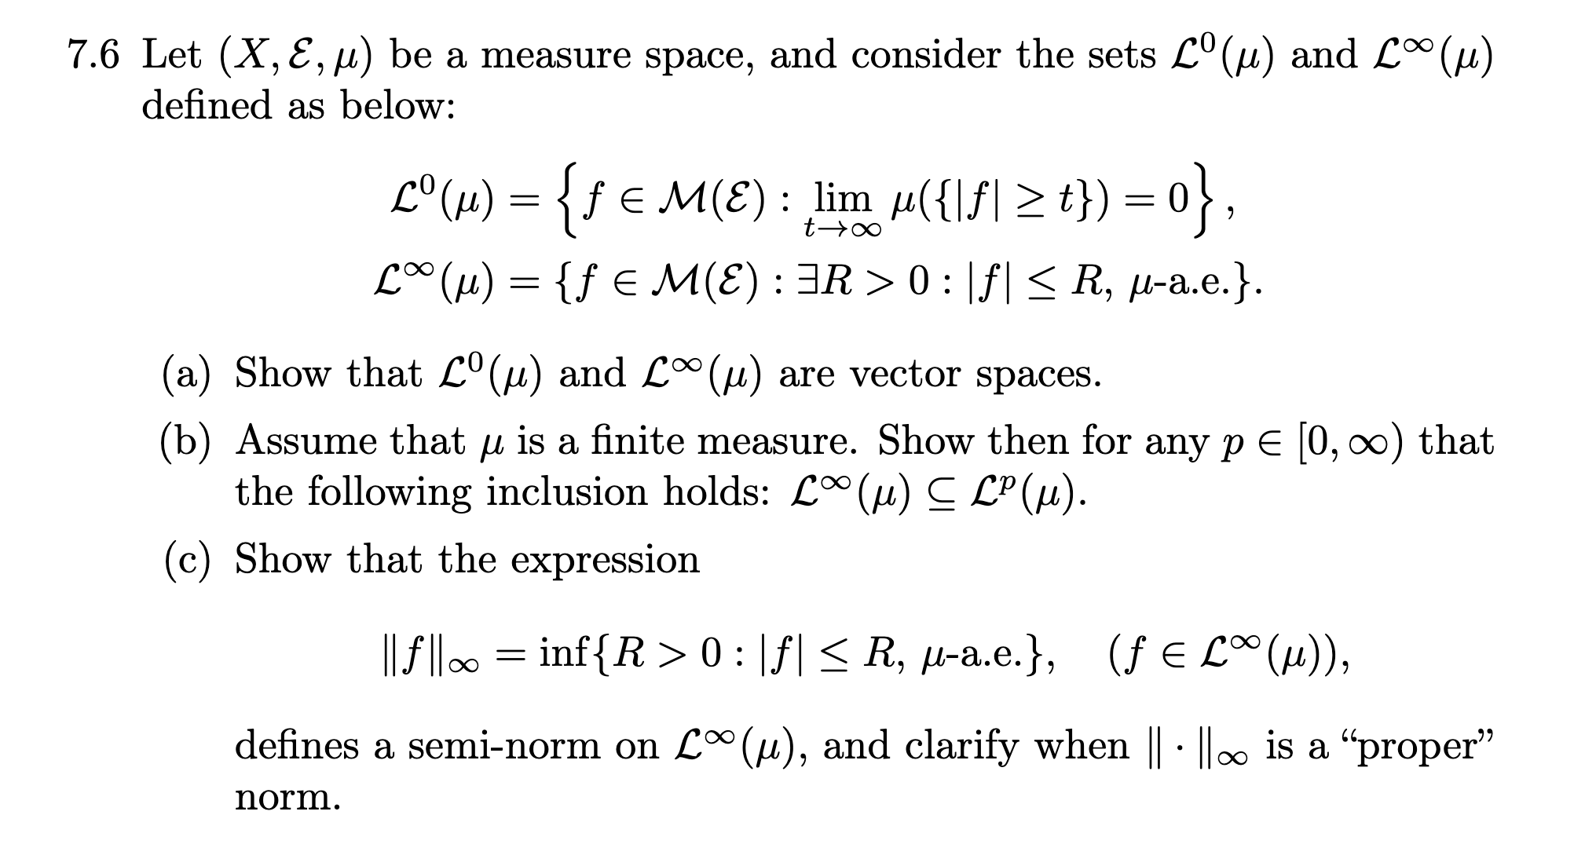

a)
Da $M(E)$ er et vektorrum skal vi blot vise betingelserne for et underrum altså:
”$L^{0}(μ)$”
Tjek om 0 er deri
$$t>0⇒μ\left(\left\{\left|f\right|≥t\right\}\right)=0⇒\lim_{t→∞}{μ\left(\left\{0≥t\right\}\right)}=0⇒0∈L^{0}(μ)$$

Lad $f,g∈L^{0}(μ)$, $α∈R∖\{0\}$
$$t≤\left|f+αg\right|⇒t≤\left|f\right|+\left|α\right|\left|g\right|⇒\frac{t}{2}≤\left|α\right|·\left|f\right| eller \frac{t}{2}≤\left|g\right|$$
Altså
$$\left\{t≤\left|f+αg\right|\right\}⊆\left\{\frac{t}{2\left|α\right|}≤\left|f\right|\right\}∪\left\{\frac{t}{2}≤\left|g\right|\right\}$$
Da
$$μ\left(\left\{t≤\left|f+αg\right|\right\}\right)≤μ\left(\left\{\frac{t}{2\left|α\right|}≤\left|f\right|\right\}\right)+μ\left(\left\{\frac{t}{2}≤\left|g\right|\right\}\right)$$
Men
$$μ\left(\left\{\frac{t}{2\left|α\right|}≤\left|f\right|\right\}\right)+μ\left(\left\{\frac{t}{2}≤\left|g\right|\right\}\right)→0 for t→∞$$
Da $f+αg∈L^{0}\left(μ\right)$

”$L^{∞}(μ)$”
Tjek om 0 er deri
$$R=1⇒R≥0⇒R≥0 μ-n.o.⇒0∈L^{∞}\left(μ\right)$$
Lad $f,g∈L^{∞}(μ)$, $α∈R∖\{0\}$
$$∃R_{f},R_{g}∈(0,∞):$$
$$\left|f\right|≤R_{f} på N_{f} hvor μ\left(N_{f}^{C}\right)=0$$
$$\left|g\right|≤R_{g} på N_{g} hvor μ\left(N_{g}^{C}\right)=0$$
For $x∈N_{f}∩N_{g}$
$$\left|f(x)+αg(x)\right|≤\left|f\left(x\right)\right|+\left|α\right|\left|g\left(x\right)\right|≤R_{f}+\left|α\right|R_{g}∈(0,∞)$$
Hvor
$$μ\left(N_{f}∩N_{g}\right)=μ\left(N_{f}^{C}∪N_{g}^{C}\right)≤μ\left(N_{f}^{C}\right)+μ\left(N_{g}^{C}\right)=0$$
Da
$$\left|f(x)+αg(x)\right|≤R_{f}+\left|α\right|R_{g} μ-n.o.$$
Og
$$f+αg∈L^{∞}(μ)$$

- lad $p∈(0,∞)$
da $\left|f\right|≤R μ-n.o.⇒{\left|f\right|}^{p}≤R^{p}μ-n.o.$
da
$$\int_{X}{{\left|f\right|}^{p}dμ}≤\int_{X}{R^{p}dμ}=μ\left(X\right)·R^{p}<∞$$
Derved må $f∈L^{p}(μ)$

For $p=0$
Da $μ\left({\left\{\left|f\right|≤R \right\}}^{C}\right)=μ\left(\{\left|f\right|>R\}\right)=0$
Da har vi altså
$$t>R⇒ μ\left(\{\left|f\right|>t\}\right)=0⇒\lim_{n→∞}{ μ\left(\{\left|f\right|>t\}\right)}=0$$
Og derved $f∈L^{0}(μ)$

c)

$${\left\|f\right\|}_{∞}=\inf{\{R>0:\left|f\right|≤R μ-n.o}\}∀f∈L^{∞}(μ)$$
n1)
mængden er aldrig tom da $f∈L^{∞}(μ)$
siden vi tager et infimum har vi at siden 0 er et undertal må det være mindre end inf altså det største undertal derved
$${\left\|f\right\|}_{∞}≥0$$

n2)
lad $α=0$
$$⇒\left|fα\right|=0≤0⇒\left|fα\right|≤0 μ-n.o.$$
$$⇒\left|fα\right|≤ϵ ∀ϵ>0$$
$$⇒\left\{R>0:\left|f\right|≤R μ-n.o\right\}=\{R>0\}$$
$$\inf\left\{R>0\right\}=0$$
$$⇒{\left\|0\right\|}_{∞}=0$$

$lad α∈R∖\{0\}$
da $\left|αf\right|=\left|α\right|\left|f\right|≤\left|α\right|{\left\|f\right\|}_{∞} μ-n.o.$
altså er $\left|α\right|{\left\|f\right\|}_{∞}$ et muligt overtal og
$${\left\|αf\right\|}_{∞}≤\left|α\right|{\left\|f\right\|}_{∞}$$
Så AFM
$${\left\|αf\right\|}_{∞}<\left|α\right|{\left\|f\right\|}_{∞}⇔\frac{{\left\|αf\right\|}_{∞}}{\left|α\right|}<{\left\|f\right\|}_{∞}$$
Men
$$⇒\left|α\right|\left|f\right|≤{\left\|αf\right\|}_{∞}<\left|α\right|{\left\|f\right\|}_{∞} μ-n.o.$$
$$⇔\left|f\right|≤\frac{{\left\|αf\right\|}_{∞}}{\left|α\right|}<{\left\|f\right\|}_{∞}$$
Men ${\left\|f\right\|}_{∞}$ er defineret til at være det mindste ”overtal” altså modstrid
Derved
$${\left\|αf\right\|}_{∞}=\left|α\right|{\left\|f\right\|}_{∞}$$
n3)
$$\left|f+g\right|≤\left|f\right|+\left|g\right|≤{\left\|f\right\|}_{∞}+{\left\|g\right\|}_{∞} μ-n.o.$$
Altså
$${\left\|f\right\|}_{∞}+{\left\|g\right\|}_{∞}∈\{R>0:\left|f+g\right|≤R μ-n.o\}$$
Da vi tager inf
$${\left\|f+g\right\|}_{∞}≤{\left\|f\right\|}_{∞}+{\left\|g\right\|}_{∞}$$

Hvornår er det en sand norm?
$${\left\|f\right\|}_{∞}=0⇔\left|f\right|≤0 μ-n.o.$$
Men
$$0≤\left|f\right| μ-n.o.$$
Altså
$${\left\|f\right\|}_{∞}=0⇔f=0 μ-n.o.$$
Vi kan derved sige at ${\left\|·\right\|}_{∞}$ er en sand norm$i tilfældet hvor$
$$f=0 μ-n.o.⇔f=0$$

7.7
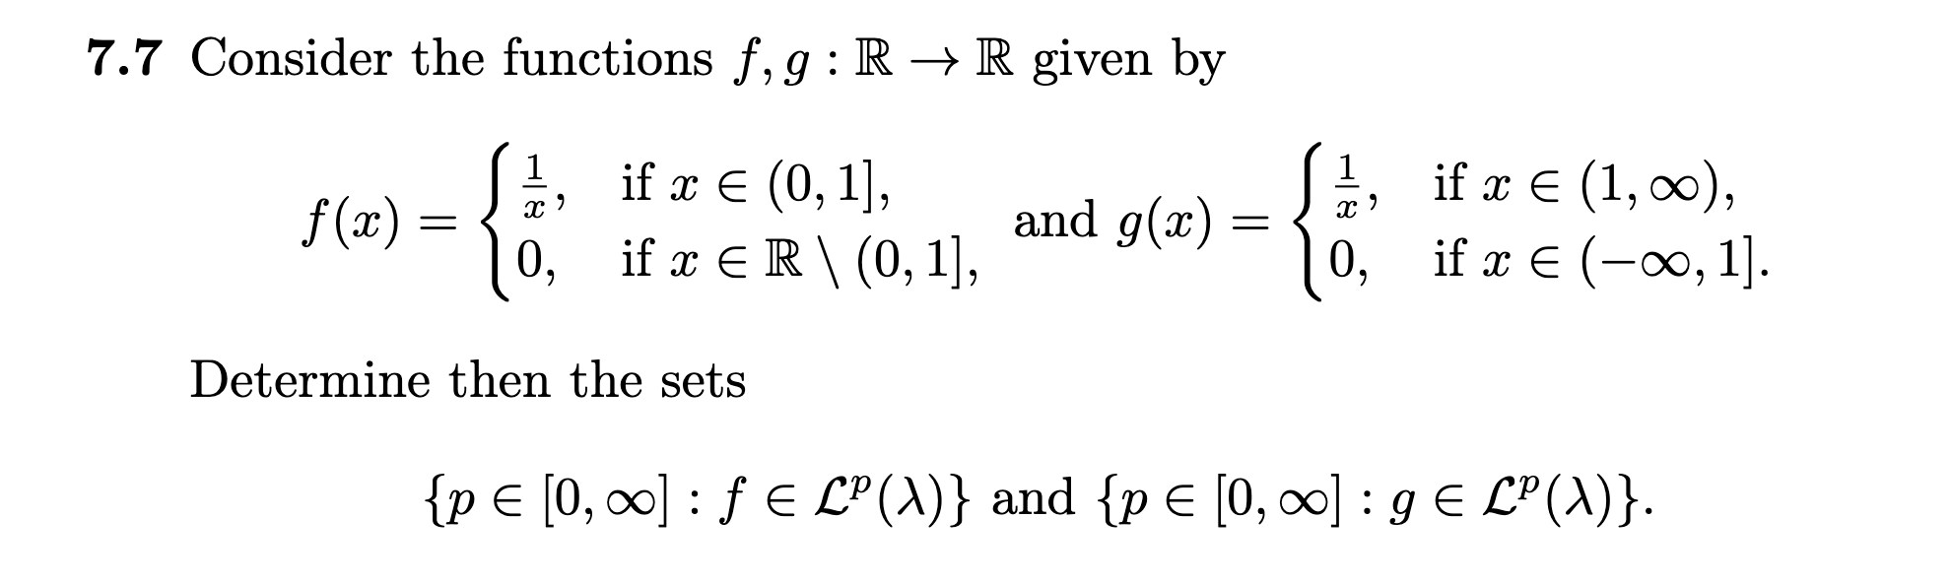
$$P_{f}=\{p∈\left[0,∞\right]:f∈L^{p}\left(λ\right)\}$$
$$P_{g}=\{p∈\left[0,∞\right]:g∈L^{p}\left(λ\right)\}$$
Begge er målelige funktioner da de er tuborg af målelige funktioner
$p=0$:
F: lad $t>0$
$$f\left(x\right)≥t⇔x∈\left(0,\frac{1}{t}\right)$$
$$⇒\left\{\left|f\right|≥t\right\}=\left(0, \min{\{\frac{1}{t},1\}}\right)$$
$$λ\left(\left\{\left|f\right|≥t\right\}\right)=\min{\{\frac{1}{t},1\}}$$

$$\min{\{\frac{1}{t},1\}}→0 for t→∞$$
Da $0∈P_{f}$
G:
Lad $t>1$
$$\left\{\left|f\right|≥t\right\}=Ø⇒λ(\left\{\left|f\right|≥t\right\}=0 for t≥1$$
Specielt
$$λ(\left\{\left|f\right|≥t\right\}→0 for t→∞$$
Da
$$0∈P_{g}$$

$p∈(0,∞)$:

vi er intraseret i integralerne m$f=\left|f\right|,g=\left|g\right|$
f:
$$\int_{R}{{\left(\left|I_{\left(0,1\right]}\left(x\right)·\frac{1}{x}\right|\right)}^{p}λ(dx)}=\int_{R}{I_{\left(0,1\right]}\left(x\right)·x^{-p}λ(dx)}$$
G:
$$\int_{R}{{\left(\left|I_{\left(1,∞\right)}\left(x\right)·\frac{1}{x}\right|\right)}^{p}λ(dx)}=\int_{R}{I_{\left(1,∞\right)}\left(x\right)·x^{-p}λ(dx)}$$
Vi ønsker at tjekke hvonår de er uendelig
Men vi har allerede regnet disse integraler i en tidligere opgave (5.15)
$$\int_{R}{I_{\left(0,1\right]}\left(x\right)·x^{-p}λ(dx)}=\left\{\begin{aligned}∞ p≥1 \\ \frac{1}{1-p} p<1\end{aligned}\right.$$
$$\int_{R}{I_{\left(1,∞\right)}\left(x\right)·x^{-p}λ(dx)}=\left\{\begin{aligned}∞ p≤1 \\ \frac{-1}{1-p} p>1\end{aligned}\right.$$
$$⇒\left(0,1\right)⊆P_{f},\left(1,∞\right)⊆P_{g}$$

$p=∞$:
F:
Lad $R>0$
$$\frac{1}{x}>R⇔\frac{1}{R}>x$$
For $x∈(0,1]$
Sæt $t=\min\left\{1,\frac{1}{R}\right\}$
$$x∈\left(0,t\right)⇒\left|f\left(x\right)\right|>R$$
Altså
$$\left\{\left|f\right|>R\right\}⊇\left(0,t\right)$$
$$⇒λ\left(\left\{\left|f\right|>R\right\}\right)≥λ\left(\left(0,t\right)\right)=t>0$$

G:

$$\left|g\right|≤1 overalt⇒\left|g\right|≤1 λ-n.o.⇒∞∈P_{g}$$

7.16
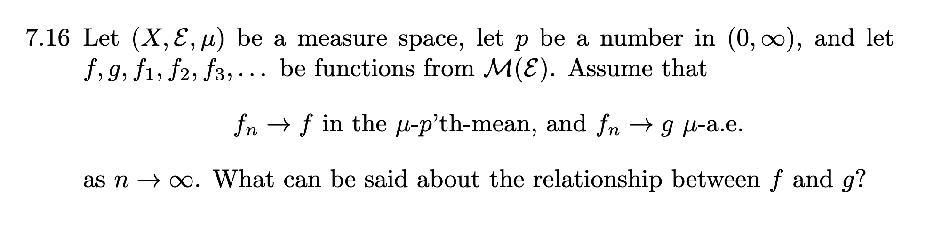
Da $f_{n}→f i μ-p^{'}te mean$ giver lemma7.4.7
$$∃{\left\{f_{n_{k}}\right\}}_{k∈N}:f_{n_{k}}→f μ-n.o.$$
Med andre ord
$$\lim_{k→∞}{f_{n_{k}}\left(x\right)}=f\left(x\right) for x∈N_{f}⊆X$$
Med $μ\left(N_{f}^{C}\right)=0$
Vi har også $f_{n}→g μ-n.o.$
Så
$$\lim_{n→∞}{f_{n}\left(x\right)}=g\left(x\right) for x∈N_{g}⊆X$$
Med $μ\left(N_{g}^{C}\right)=0$
Altså for $x∈N_{f}∩N_{g}$ har vi begge
Men enhver delfølge må konvergerer mod samme grænse når grænsen eksisterer
Altså
$$f\left(x\right)=\lim_{k→∞}{f_{n_{k}}\left(x\right)}=\lim_{n→∞}{f_{n}\left(x\right)}=g\left(x\right) for x∈N_{f}∩N_{g}$$
Hvor vi bemærker
$$μ\left({\left(N_{f}∩N_{g}\right)}^{C}\right)=μ\left(N_{f}^{C}∪N_{g}^{C}\right)≤μ\left(N_{f}^{C}\right)+μ\left(N_{g}^{C}\right)=0$$
Altså
$$f=g μ-n.o.$$

Kapitel 9
9.2
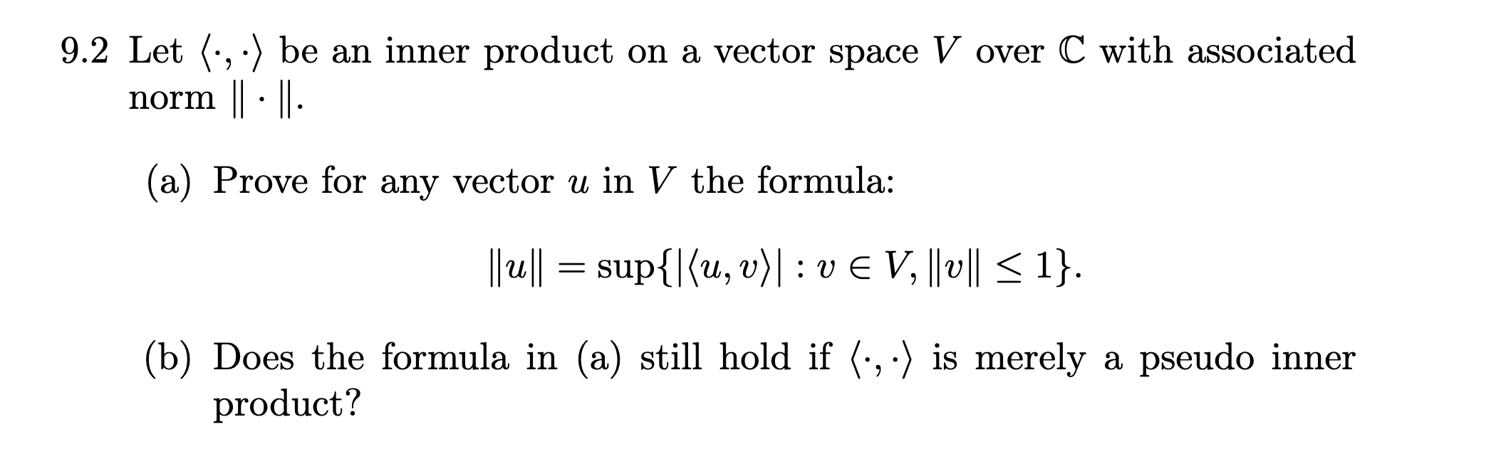
- $\left\|u\right\|=0$:
giver cauchy schwarz
$$\left|〈u,v〉\right|≤\left\|u\right\|\left\|v\right\|=0∀v∈V$$
Altså er supremumet 0
(0 er overtal og 0 er i ængden altså skal sup være 0)
$\left\|u\right\|>0$:
Vælg
$$v=\frac{u}{\left\|u\right\|}∈V$$
$$\left\|v\right\|=\frac{\left\|u\right\|}{\left\|u\right\|}=1$$
Da
$$\left|〈u,v〉\right|=\left|〈u,\frac{u}{\left\|u\right\|}〉\right|=\frac{1}{\left\|u\right\|}\left|〈u,u〉\right|=\frac{{\left\|u\right\|}^{2}}{\left\|u\right\|}=\left\|u\right\|$$
Lad $v∈V:\left\|v\right\|≥1$
Da giver CS
$$\left|〈u,v〉\right|≤\left\|u\right\|\left\|v\right\|≤\left\|u\right\|$$
Da er $\left\|u\right\|$ et overtal, og i mængden da
Sup=$\left\|u\right\|$
- Vi bruger aldrig ip4 i udledningerne
Hvis vi havde splittet op ti tilfælde hvor $u=0,u≠0$ havde det været en anden sag

9.4
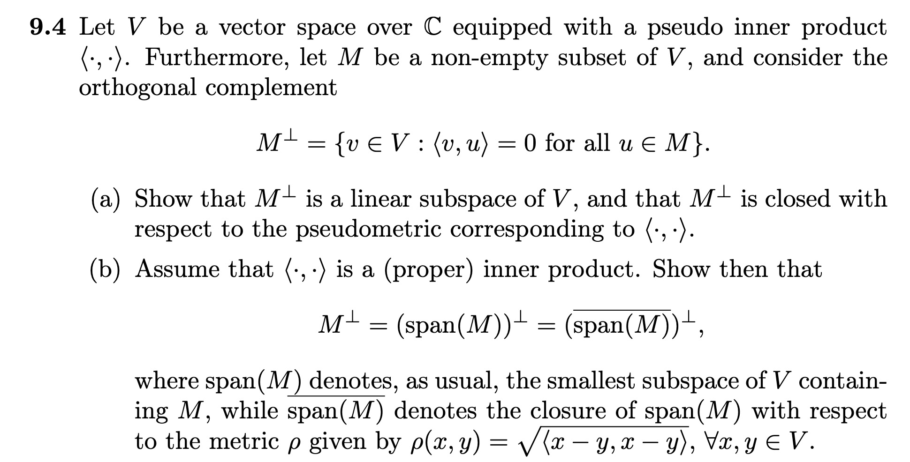
a)
underrum:
”$0∈M^{⊥}$”
$0∈V$ da V er et vektorrum
$$〈0,u〉=0∀u∈V$$
Specielt for $v∈M⇒0∈M^{⊥}$
Lad $x,y∈M^{⊥},α∈C$
Lad $u∈M$
$$⇒〈x+αy,u〉=〈x,u〉+α〈y,u〉=0+α0=0$$
$$⇒x+αy∈M^{⊥}$$
Derved er $M^{⊥}$ et underrum

lukket:
lad ${\left\{v_{n}\right\}}_{n∈N}⊆M^{⊥}$ hvor $v_{n}→v for n→∞$ i den forstand $\left\|v-v_{n}\right\|→0 for n→∞$
lad $u∈M$
kontinuitet i det indre produkt giver
$$〈u,v〉=〈\lim_{n→∞}{u_{n}},v〉=\lim_{n→∞}{〈u_{n},v〉}=\lim_{n→∞}{0}=0$$
$$⇒u∈M^{⊥}$$
Da er $M^{⊥}$ lukket

b)
vis
$$M^{⊥}={\left(span\left(M\right)\right)}^{⊥}={\left(\overline{span\left(M\right)}\right)}^{⊥}$$
$$M⊆Span\left(M\right)⊆\overline{span\left(M\right)}$$
$$⇒ M^{⊥}⊇{\left(span\left(M\right)\right)}^{⊥}⊇{\left(\overline{span\left(M\right)}\right)}^{⊥}$$
” $M^{⊥}⊆{\left(span\left(M\right)\right)}^{⊥}$”
Lad $x∈M^{⊥}$,$y∈span\left(M\right)$
$$⇒y=\sum_{i=1}^{n}{u_{i}·α_{i}}$$
Med $u_{i}∈M,α_{i}∈C∀i∈\{1,…,n\}$
Da
$$〈x,y〉=〈x,\sum_{i=1}^{n}{u_{i}·α_{i}}〉=\sum_{i=1}^{n}{\overline{α_{i}}〈x,u_{i}〉}=0$$
Her starter vi med at flippe det indre produkt,trækker scalaren ud og flipper tilbage igen,
Hvorefter vi bruger $x∈M^{⊥}⇒〈x,u_{i}〉=0$
$$⇒x∈{\left(span\left(M\right)\right)}^{⊥}$$
Derved $M^{⊥}⊆{\left(span\left(M\right)\right)}^{⊥}$

” ${\left(span\left(M\right)\right)}^{⊥}⊆{\left(\overline{span\left(M\right)}\right)}^{⊥}$”
Lad $x∈(span{\left(M\right))}^{⊥} ,y∈\overline{span\left(M\right)}$
$$⇒∃{\left\{y_{n}\right\}}_{n∈N}⊆span\left(M\right):\lim_{n→∞ }{y_{n}}=y$$
Kontinuitet af det indre produkt giver da
$$〈x,y〉=\lim_{n→∞}{〈x,y_{n}〉}=\lim_{n→∞}{0}=0$$
$$⇒x∈{\left(\overline{span\left(M\right)}\right)}^{⊥}$$
$$⇒{\left(span\left(M\right)\right)}^{⊥}⊆{\left(\overline{span\left(M\right)}\right)}^{⊥}$$
Og vi er færdige

9.6
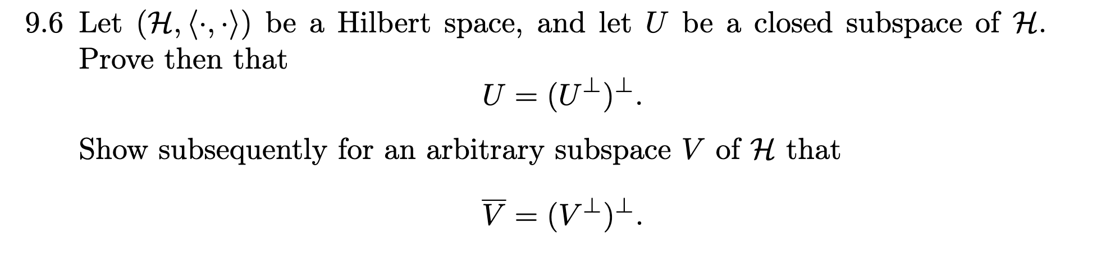

Nok at vise $\overline{V}={\left(V^{⊥}\right)}^{⊥}$
Da hvis U er lukket $U=\overline{U}$
”$⊆$”
Lad $x∈\overline{V}$
Nok at vise $〈x,y〉=0∀y∈V^{⊥}$
Lad $y∈V^{⊥}$

$$x∈\overline{V}⇒∃{\left\{x_{n}\right\}}_{n∈N}⊆V:x_{n}→x for n→∞$$
Ved kontinuitet af det indre produkt har vi
$$〈x,y〉=〈\lim_{n→∞}{x_{n}},y〉=\lim_{n→∞}{〈x_{n},y〉}$$
Men $x_{n}∈V,y∈V^{⊥}⇒〈x_{n},y〉=0∀n∈N$
$$\lim_{n→∞}{〈x_{n},y〉}=\lim_{n→∞}{0}=0$$
$$⇒\overline{V}⊆{\left(V^{⊥}\right)}^{⊥}$$
”$\overline{V}⊇{\left(V^{⊥}\right)}^{⊥}$”
Ortogonale complimenter er lukket(følger af kontinuitet af det indre produkt) opgave 9.4
Lad $x∈{\left(V^{⊥}\right)}^{⊥}$ da giver projektionstheoremet
$$x=u+w:$$
$$u∈\overline{V}⊆{\left(V^{⊥}\right)}^{⊥},w∈{\overline{V}}^{⊥}⊆V^{⊥}$$
Følger af $\overline{V}⊇V⇒{\overline{V}}^{⊥}⊆V^{⊥}$
${\left(V^{⊥}\right)}^{⊥}$ er et vektorrum
$$w=x-w∈{\left(V^{⊥}\right)}^{⊥}$$
Altså $w∈{\left(V^{⊥}\right)}^{⊥}∩V^{⊥}⇒w=0$
(for en sand norm)
$$⇒x=u+w=u∈\overline{V}$$
Derved $\overline{V}⊇{\left(V^{⊥}\right)}^{⊥}$
Og vi er færdige

Kapitel 11
11.5
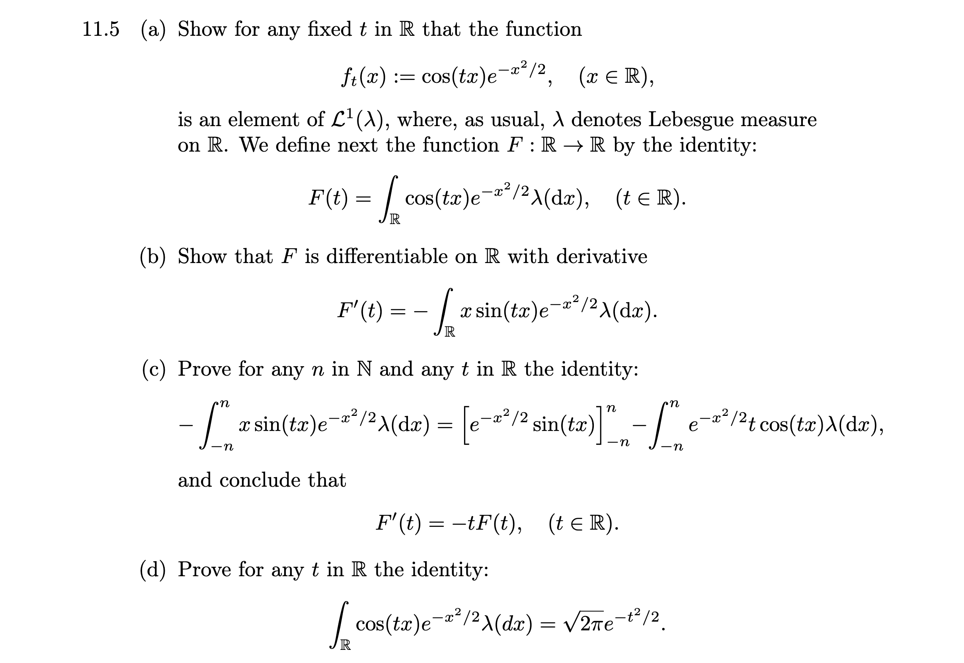

A1) bemærk $\left|f_{t}\left(x\right)\right|≤e^{-\frac{x^{2}}{2}}$
$$\int_{R}{e^{-\frac{x^{2}}{2}}λ(dx)}=\sqrt{π2}$$
ved vi da vi kender normalfordelingen (ret godt )
$$⇒\int_{R}{\left|f_{t}\left(x\right)\right|λ(dx)}<∞⇒f_{t}∈L^{1}\left(λ\right)∀t∈R$$

B) find resultat fra tidligere opgave
$$F\left(t\right)=\int_{R}{\cos\left(x·t\right)·e^{-\frac{x^{2}}{2}}λ(dx)}$$
Vis F diff med $F^{'}\left(t\right)=-\int_{R}{\frac{∂}{∂t}f_{t}\left(x\right)λ(dx)}$
Vi vil bruge 5.25

5.25(hvad siger den?)
Lad $(X,E,μ)$ være et målrum lad $I⊆R$ være et åbent interval
Lad $f:X×I→R$ og definer
$$f_{t}\left(x\right)=f\left(x,t\right) ∀x∈X$$
$$f_{x}\left(t\right)=f\left(x,t\right)∀t∈I$$
Hvis
- $f_{t}∈L^{1}\left(μ\right)∀t∈I$
- $f_{x}:I→R diff in I ∀x∈X$
- $∃g∈\overline{M}{\left(E\right)}^{+}:\int_{X}{gdμ}<∞,\left|\frac{∂}{∂t}f\left(x,t\right)\right|≤g\left(x\right)∀x∈X,t∈I$
Da for
$$F\left(t\right)=\int_{X}{f\left(x,t\right)μ\left(dx\right)}$$
Har vi
$$F^{'}\left(t\right)=\int_{X}{\frac{∂}{∂t}f\left(x,t\right)μ(dx)}$$

Lad os tjekke betingelserne
- Vist i (a)
- $f^{x}\left(t\right)=f\left(x,t\right)=\cos\left(x·t\right)·e^{-\frac{x^{2}}{2}}$ er sammensætningen af diff funktioner og da diff
- Vi differantierer den lige
$$\frac{∂}{∂t}f\left(x,t\right)=-x·\sin\left(x·t\right)·e^{-\frac{x^{2}}{2}}$$
Vi ser
$$\left|-x·\sin\left(x·t\right)·e^{-\frac{x^{2}}{2}}\right|≤\left|x\right|·e^{-\frac{x^{2}}{2}}$$
Da skal vi bare sikre os begrænset integrale
Vi bruger der sædvanelige monoton konvergens trik
$$I_{\left[-n,n\right]}(x)\left|x\right|·e^{-\frac{x^{2}}{2}}↑\left|x\right|·e^{-\frac{x^{2}}{2}}$$
Da
$$\int_{R}{\left|x\right|·e^{-\frac{x^{2}}{2}}}=\lim_{n→∞}{R\int_{-n}^{n}{\left|x\right|·e^{-\frac{x^{2}}{2}}}}$$
Da funktionen er lige
$$R\int_{-n}^{n}{\left|x\right|·e^{-\frac{x^{2}}{2}}}=2·R\int_{0}^{n}{x}·e^{-\frac{x^{2}}{2}}$$
Fundamental theorem of calculus
$${\left(-e^{-\frac{x^{2}}{2}}\right)}^{'}=x·e^{-\frac{x^{2}}{2}}$$

$$2·R\int_{0}^{n}{x}·e^{-\frac{x^{2}}{2}}=2·{\left[-e^{-\frac{x^{2}}{2}}\right]}_{0}^{n}=2-2e^{-\frac{n^{2}}{2}}→2$$

Derved
$$F^{'}\left(t\right)=\int_{X}{-x·\sin\left(x·t\right)·e^{-\frac{x^{2}}{2}}}λ(dx)$$

- Integration by parts
Analyse 2:
Partiel integration
$$u=e^{-\frac{x^{2}}{2}},v=sin(t·x)$$
$$u^{'}=-xe^{-\frac{x^{2}}{2}},v^{'}=t cos\left(x\right)$$
Derved
$${\left[e^{-\frac{x^{2}}{2}}·sin\left(t·x\right)\right]}_{-n}^{n}=\int_{-n}^{n}{t·\cos\left(tx\right)}e^{-\frac{x^{2}}{2}}λ\left(dx\right)+\int_{-n}^{n}{-xe^{\frac{-x^{2}}{2}}·\sin\left(tx\right)}$$
$$⇔-\int_{-n}^{n}{xe^{\frac{-x^{2}}{2}}·\sin\left(tx\right)}={\left[e^{-\frac{x^{2}}{2}}·sin\left(t·x\right)\right]}_{-n}^{n}-\int_{-n}^{n}{t·\cos\left(tx\right)}e^{-\frac{x^{2}}{2}}λ\left(dx\right)$$
Tag grænsen
DC er opfyldt for $f^{t}∈L^{1}(λ)$ og $\frac{∂}{∂t}f(x,t)$ har vi sikret os
Da
$$\begin{aligned}F^{'}\left(t\right)=\lim_{n→∞}{-\int_{-n}^{n}{xe^{\frac{-x^{2}}{2}}·\sin\left(tx\right)}}=\lim_{n→∞}{{\left[e^{-\frac{x^{2}}{2}}·sin\left(t·x\right)\right]}_{-n}^{n}}-\int_{-n}^{n}{t·\cos\left(tx\right)}e^{-\frac{x^{2}}{2}}λ\left(dx\right)\#\left(\#\right)\end{aligned}$$

Kigger lige på indmaden
$$e^{-\frac{n^{2}}{2}}\sin\left(t·n\right)-e^{-\frac{n^{2}}{2}}·\sin\left(-n·t\right)=0$$
$$\#=\lim_{n→∞}{-\int_{-n}^{n}{t·\cos\left(tx\right)}e^{-\frac{x^{2}}{2}}λ\left(dx\right)}=-t·F'(t)$$

- Løsningen til $y^{'}\left(t\right)+ty\left(t\right)=0,y\left(0\right)=\sqrt{2π}$ er entydig pr hint

Lad $F\left(0\right)=\sqrt{2π}$ per 11.4
Da er F løsning til diff lining ovenover

Da skal vi bare tjekke at
$$y\left(t\right)=\sqrt{2π}e^{-\frac{t^{2}}{2}}$$
Også er
$$y\left(0\right)=\sqrt{2π}$$
$$y^{'}\left(t\right)=\sqrt{2π}·e^{-\frac{t^{2}}{2}}·-t$$
$$y^{'}\left(t\right)+t·y\left(t\right)=\sqrt{2π}·e^{-\frac{t^{2}}{2}}·-t+t·\sqrt{2π}e^{-\frac{t^{2}}{2}}=0$$
Da er begge løsninger til diff lining med ens start og vi må derved have
$$F\left(t\right)=\int_{R}{\cos\left(tx\right)·e^{-\frac{x^{2}}{2}}λ(dx)}$$

Kapitel 12
12.2
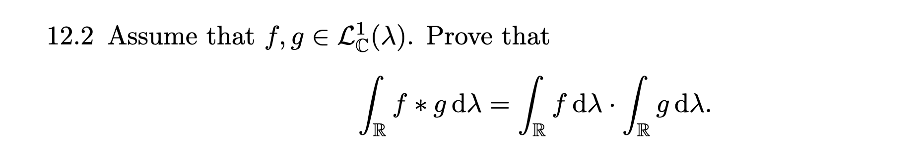
$$f,g∈L_{C}^{1}\left(λ\right)⇒Δ{\left(f,g\right)}^{C} er en nul-mængde,f\left(x-y\right)g\left(y\right)∈L_{C}^{1}\left(λ^{2}\right)$$
$$⇒\int_{R}{f⋆g dλ}=\int_{R}{\left(\int_{R}{f\left(x-y\right)g\left(y\right)λ\left(dy\right)}\right)λ(dx)}$$
Vi kan da bruge fubini
$$\int_{R}{\left(\int_{R}{f\left(x-y\right)g\left(y\right)λ\left(dy\right)}\right)λ(dx)}=\int_{R}{\left(\int_{R}{f\left(x-y\right)g\left(y\right)λ\left(dx\right)}\right)λ(dy)}$$
$$=\int_{R}{g\left(y\right)\left(\int_{R}{f\left(x-y\right)λ\left(dx\right)}\right)λ\left(dy\right)}$$
Og at $λ$ er translation invariant
$$=\int_{R}{g\left(y\right)\left(\int_{R}{f\left(x\right)λ\left(dx\right)}\right)λ\left(dy\right)}=\int_{R}{g\left(y\right)λ\left(dy\right)}\int_{R}{f\left(x\right)λ\left(dx\right)}$$

12.5
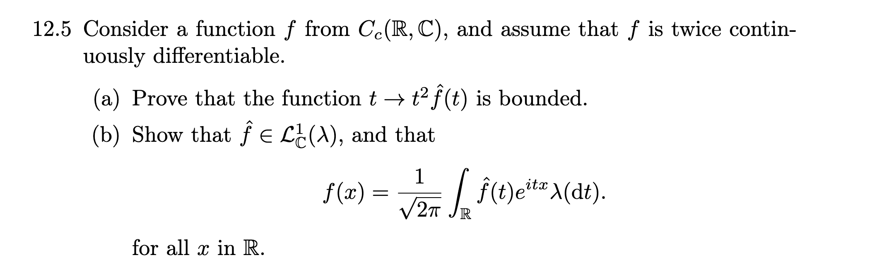

Øvelse 12.1 giver $f∈C_{c}\left(R,C\right)⇒f er uniformt kontinuert$
Først viser vi $f∈C_{c}^{n}\left(R,C\right)⇒f^{'}∈C_{C}^{n-1}(R,C)$
F’ er kontinuert differentiabel per def af $C_{c}^{n}$
$$supp\left(f\right) kopakt⇒supp{\left(f\right)}^{C} åben$$
Lad $x∈supp{\left(f\right)}^{C}⇒f\left(x\right)=0$
Åbenhed giver da også $∃r>0:\left\|x-y\right\|<r⇒f\left(y\right)=0$
Da giver defintionen af den afledte $f^{'}\left(x\right)=0$
$$⇒supp{\left(f\right)}^{C}⊆supp{\left(f^{'}\right)}^{C}$$
$$⇒supp\left(f\right)⊇supp(f^{'})$$
Support er lukket per definitionen
Og begrænset da delmængde da
$$supp\left(f^{'}\right) kompakt$$
$$f^{'}∈C_{c}(R,C)$$
Nu viser vi $C_{c}\left(R,C\right)⊆L_{C}^{1}(λ)$
Lad $f∈C_{c}\left(R,C\right)$ $∃C⊆R:C kompakt,ikke tom , f\left(x\right)=0 for x∈C^{C}$
Argumenterer nu for $0∈f\left(C\right)$
$$C kompakt,ikke tom⇒C ikke åben⇒∃x∈C:B\left(x,r\right)∩C^{c}≠Ø∀r>0$$
Byg følge ${\left\{x_{n}\right\}}_{n∈N}⊆R:x_{n}→x for n→∞$
Hvor $x_{n}∈B\left(x,\frac{1}{n}\right)∩C^{c}$
Følgekontinuitet giver da
$$f\left(x\right)=f\left(\lim_{n→∞}{x_{n}}\right)=\lim_{n→∞}{f(x_{n})}=0$$
Da $0∈f(C)$

Da $f\left(C\right)=f(R)$
Kontinuert afbilleding på kompakt mængde er kompakt
Derved $∃K,R∈(0,∞):\left|f\right|≤KI_{\left[-R,R\right]}$
Hvor $C⊆\left[-R,R\right]$
Da $\int_{R}{\left|f\right|dλ}≤\int_{R}{KI_{\left[-R,R\right]}}=K·2R<∞$
$$→f∈L_{C}^{1}(λ)$$
Derved $C_{c}\left(R,C\right)⊆L_{C}^{1}(λ)$
$$⇒f,f^{'},f^{''}∈C_{c}\left(R,C\right)⊆L_{C}^{1}(λ)$$
Prop 12.1.6 giver da siden $f,f^{'}er kont diff, f^{'},f^{''}∈L_{C}^{1}(λ)$
$$\hat{f^{''}}\left(t\right)=it·\hat{f^{'}}\left(t\right)=-t^{2}\hat{f}\left(t\right)$$
Da giver 12.1.3
$$\left|t^{2}\hat{f}\left(t\right)\right|=\left|\hat{f^{''}}\left(t\right)\right|≤\sup_{t∈R}\left|\hat{f^{''}}\left(t\right)\right|≤\frac{1}{\sqrt{2π}}·{\left\|f^{''}\right\|}_{1}<∞$$
Da er udtrykket begrænset

- Opgave 12.3 giver os at det er nok at vise $\hat{f},f∈L_{C}^{1}\left(λ\right),f-kontinuert på R$

Bevis for 12.3
Nok at vise
$$\lim_{σ↓0}{f⋆ϕ_{σ}(x)}=f\left(x\right)∀x∈R$$
Fra bevis for invertionssætningen
$$f⋆ϕ_{σ}\left(x\right)=\int_{R}{f\left(x-y\right)ϕ_{σ}\left(y\right)λ\left(dy\right)}$$
Lad $ϵ>0$
$$\left|f\left(x\right)-f⋆ϕ_{σ}\left(x\right)\right|=\left|\int_{R}{\left(f\left(x-y\right)-f\left(x\right)\right)ϕ_{σ}\left(y\right)λ\left(dy\right)}\right|$$
$$≤\int_{R}{\left|f\left(x-y\right)-f\left(x\right)\right|ϕ_{σ}\left(y\right)λ\left(dy\right)}$$
Lad $ϵ>0$ f kont $⇒∃δ>0:\left|x-y\right|<δ→\left|f\left(x-y\right)-f\left(x\right)\right|$
$$=\int_{(x-δ,x+δ)}{\left|f\left(x-y\right)-f\left(x\right)\right|ϕ_{σ}\left(y\right)λ\left(dy\right)}+\int_{{\left(x-δ,x+δ\right)}^{C}}{\left|f\left(x-y\right)-f\left(x\right)\right|ϕ_{σ}\left(y\right)λ\left(dy\right)}$$
$$=\left(Δ\right)+(\#)$$
$$Δ≤ϵ·\int_{x-δ,x+δ}{ϕ_{σ}\left(y\right)λ\left(dy\right)}≤ϵ·{\left\|ϕ_{σ}\right\|}_{1}→0 per kontinuitetsargument$$
$$\#=\int_{{\left(x-δ,x+δ\right)}^{C}}{\left|f\left(x-y\right)-f\left(x\right)\right|ϕ_{σ}\left(y\right)λ\left(dy\right)}$$
$$≤\int_{{\left(δ,δ\right)}^{C}}{\left|f\left(x-y\right)\right|ϕ_{σ}\left(y\right)λ\left(dy\right)}+\int_{{\left(δ,δ\right)}^{C}}{\left|f\left(x\right)\right|ϕ_{σ}\left(y\right)λ\left(dy\right)}$$
$$≤{\left\|f\right\|}_{1}·\sup_{t∈{\left(δ,δ\right)}^{C}}{ϕ_{σ}\left(t\right)}+\left|f\left(x\right)\right|·\int_{{\left(δ,δ\right)}^{C}}{ϕ_{σ}\left(y\right)λ\left(dy\right)}$$
Nok at vise $ϕ_{σ}\left(t\right)→0 for σ↓0 når t≠0$
$$ϕ_{σ}\left(t\right)=\frac{1}{\sqrt{2πσ^{2}}}·e^{-\frac{x^{2}}{2σ^{2}}}$$
For $t≠0$er grænsen entydig da eksponentialfunktionen vider pr analyse 2
Altså
$$\frac{1}{\sqrt{2πσ^{2}}}·e^{-\frac{x^{2}}{2σ^{2}}}=\frac{1}{\sqrt{2π}}·\frac{1}{σ}·e^{-{\left(\frac{x}{σ}\right)}^{2}·\frac{1}{2}}→0 for σ→0$$

Da ${\left\|f\right\|}_{1}·\sup_{t∈{\left(-δ,δ\right)}^{C}}{ϕ_{σ}\left(t\right)}→0 for σ→0$
For den anden side giver monoton konvergens(nedad) i en hale at
$$\frac{1}{\sqrt{2π}}·\frac{1}{σ}·e^{-{\left(\frac{x}{σ}\right)}^{2}·\frac{1}{2}} monoton for σ<\left|x\right|$$
Specielt for $δ$
I tvivl diff ift $σ$
Da $σ_{\frac{δ}{n}}\left(y\right)↓0 for n→∞$

$$\lim_{σ→0}{\int_{{\left(δ,δ\right)}^{C}}{ϕ_{σ}\left(y\right)λ\left(dy\right)}}=\int_{(-δ,δ)}{0λ(dy)}=0$$
Derved
$\left(Δ\right)+\left(\#\right)→0 for σ→0$og vi er færdige

Altså egentlig
$$lad ϵ>0væ\lg{δ>0:\left|y\right|<δ→\left|f\left(x\right)-f(x-y)\right|<\frac{ϵ}{4} }$$
$$væ\lg{δ>σ>0}: {\left\|f\right\|}_{1}·\sup_{t∈{\left(δ,δ\right)}^{C}}{ϕ_{σ}\left(t\right)}<\frac{ϵ}{4}$$
$$\int_{{\left(δ,δ\right)}^{C}}{ϕ_{σ}\left(y\right)λ\left(dy\right)}<\frac{ϵ}{4}$$
Da $\left|f\left(x\right)-f⋆ϕ_{σ}(x)\right|<ϵ$

Da må vi have $f\left(x\right)=\hat{\hat{f}}\left(-x\right)∀x∈R$

Da mangelr vi bare $\hat{f}∈L_{C}^{1}(λ)$
Per (a) har vi $\left|\hat{f}(x)\right|≤\left|\hat{f}\left(x\right)\right|I_{\left[-1,1\right]}\left(x\right)+\frac{1}{\sqrt{2π}}·\frac{{\left\|f\right\|}_{1}}{x^{2}}·I_{{\left[-1,1\right]}^{C}}\left(x\right)$
Kig på
$$\int_{R}{\left|\hat{f}\left(x\right)\right|λ(dx)}≤\int_{R}{\left|\hat{f}\left(x\right)\right|I_{\left[-1,1\right]}\left(x\right)λ\left(dx\right)}+\int_{R}{\frac{1}{\sqrt{2π}}·\frac{{\left\|f\right\|}_{1}}{x^{2}}·I_{{\left[-1,1\right]}^{C}}\left(x\right)λ(dx)}$$
$12.1.3$ giver da igen sammen med at funktionen er lige
$$≤\frac{2}{\sqrt{2π}}·{\left\|f\right\|}_{1}+\frac{{\left\|f\right\|}_{1}}{\sqrt{2π}}·2\int_{1}^{∞}{\frac{1}{x^{2}}}λ\left(dx\right)=\frac{4{\left\|f\right\|}_{1}}{\sqrt{2π}}$$

Og vi er færdige

Kapitel 13

13.3
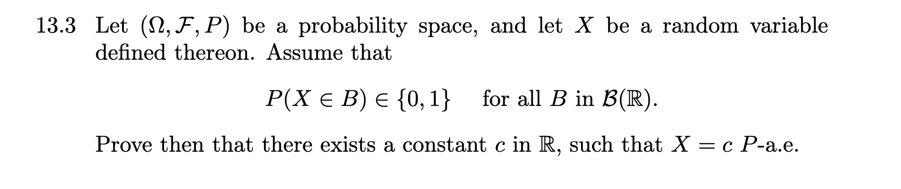

Vis først $∃c∈R:P_{X}=δ_{\left\{c\right\}}$

Lad $c=inf⁡\{t∈R:F_{X}\left(t\right)=1\}$ hvor $F\left(t\right)=P(\left\{X≤t\right\})$
For et sansynlighedsmål må vi have
$$\lim_{t→-∞}{F_{X}(t)}=P_{X}\left(Ø\right)=0,\lim_{t→∞}{F_{X}(t)}=P_{X}(R)=1$$
Derfra må vi have at der findes grænser hvor hhv den nedre og øvre grænse må blive den faste værdi 1eller 0 da funktionen kun tager 2 værdier når vi rammer 1 ra bunden er vi 1 for evigt og visa versa
Nu skal vi blot vise de 2 mål er er ens

Nok at vise at $P_{X}\left(B\right)=δ_{c}\left(B\right)∀B∈\{\left(-∞,t\right]|t∈R\}$ per 2.2.1 da mængden er $∩-stabil$

Lad $t∈R$ hvis $c≤t$ må vi have
$$P_{X}\left(\left(-∞,t\right]\right)=F_{X}\left(t\right)=1=δ_{c}(\left(-∞,t\right])$$
Per definition af c og monotonicitet af $F_{X}$

Hvis $t<c$
$$P_{X}\left(\left(-∞,t\right]\right)=F_{X}\left(t\right)=0=δ_{c}(\left(-∞,t\right])$$
Per def af c da F kun kan tage 2 værdier og ikke kan tage værdi 1 da vi da ville have modstrid af konstruktionen af c
Siden at begge mål også er endelige er vi færdige
$$P_{X}=δ_{c}$$

Da viser vi $X=c$ P-n.o.
$$\left\{X=c\right\}=\left\{ω∈Ω:X\left(ω\right)=c\right\}=X^{-1}(\left\{c\right\})$$
$$P\left(X^{-1}\left(\left\{c\right\}\right)\right)=P_{X}\left(\left\{c\right\}\right)=δ_{\left\{c\right\}}\left(\left\{c\right\}\right)=1$$
$$⇒P\left(X^{-1}{\left(\left\{c\right\}\right)}^{C}\right)=1-P\left(X^{-1}\left(\left\{c\right\}\right)\right)=0⇒X=c P-n.o.$$

Ugens integraler
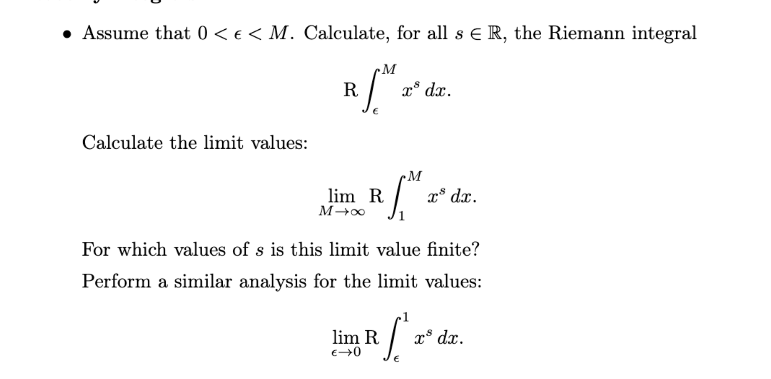
- 1
$$R\int_{ϵ}^{M}{x^{s}dx}=\left\{\begin{aligned}\log{(M)}-\log\left(ϵ\right) s=-1 \\ \frac{1}{s+1}\left(M^{s+1}-ϵ^{s+1}\right) s≠-1\end{aligned}\right.$$
- Vi tager grænser
$s>-1$:
$$\lim_{M→∞}{\frac{1}{s+1}\left(M^{s+1}-1\right)}→∞ for M→∞$$
Da
$$\frac{1}{1+s}>0,M^{s+1}→∞$$

$s=-1$:
$$\log{(M)}-0→∞ for M→∞$$

$s<-1$:
$$\frac{1}{s+1}\left(M^{s+1}-1\right)→\frac{-1}{s+1}1>0 for M→∞$$
Da
$$\frac{1}{s+1}<0,M^{s+1}→0 for M→∞$$
Altså begrænset for $s<-1$
Ellers ikke

- Tager grænser
$s>-1$:
$$\lim_{M→∞}{\frac{1}{s+1}\left(1-ϵ^{s+1}\right)}→\frac{1}{s+1} for ϵ→0$$
Da
$$\frac{1}{1+s}>0,ϵ^{s+1}→0$$

$s=-1$:
$$-\log\left(ϵ\right)=\log\left(\frac{1}{ϵ}\right)→∞ for ϵ→0$$
$s<-1$:
$$\frac{1}{s+1}\left(1-ϵ^{s+1}\right)→∞ for ϵ→0$$
Da
$$\frac{1}{s+1}<0,ϵ^{s+1}→∞ for ϵ→0$$
Altså begrænset for $s>-1$
Vi har lavet den her øvelse 3 gange i det her kursus…

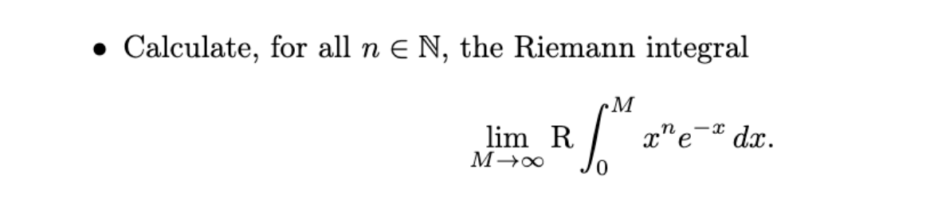

Først bemærker vi
Partiel integration:
$$u=x^{n},v^{'}=e^{-x}$$
$$⇒u^{'}=n·x^{n-1},v=-e^{-x}$$

$$R\int_{0}^{M}{x^{n}e^{-x}dx}={\left[-x^{n}·e^{-x}\right]}_{0}^{M}+n·R\int_{0}^{M}{x^{n-1}e^{-x}dx}$$
$$=-M^{n}·e^{-M}+n·R\int_{0}^{M}{x^{n-1}e^{-x}dx}$$
Start: n=1
Partiel integration
$$R\int_{0}^{M}{x·e^{-x}dx}$$
$$={\left[-x·e^{-x}\right]}_{0}^{M}+R\int_{0}^{M}{e^{-x}dx}={\left[-x·e^{-x}\right]}_{0}^{M}+{\left[-e^{-x}\right]}_{0}^{M}=-M·e^{-M}-e^{-M}+1$$
Med $\lim_{M→∞}{-M·e^{-M}-e^{-M}+1}=1=1!$

Antag for n
Hvilket giver
$$\lim_{M→∞}{R\int_{0}^{M}{x^{n+1}e^{-x}dx}}=\lim_{M→∞}{{\left[-x^{n}·e^{-x}\right]}_{0}^{M}+(n+1)·R\int_{0}^{M}{x^{n}e^{-x}dx}}$$

$$=\lim_{M→∞}{-M^{n}·e^{-M}+(n+1)·R\int_{0}^{M}{x^{n}e^{-x}dx}}$$
$$=\left(n+1\right)·\lim_{M→∞}{R\int_{0}^{M}{x^{n-1}e^{-x}dx}}=\left(n+1\right)·n!=\left(n+1\right)!$$
Qed

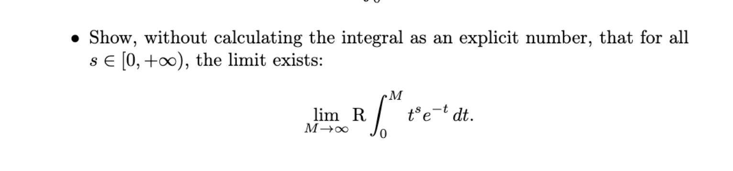
Nok at vise at integralet er opadtil begrænset da integralet er monotont da funktionen vi integrerer over :
$$f_{M}(t)=I_{\left[0,M\right]}\left(t\right)·t^{s}·e^{-t}$$
Er positiv osv.
Omskriv til følge
$$f_{n}\left(t\right)=I_{\left[0,n\right]}\left(t\right)·t^{s}·e^{-t}$$
Se $f_{n}↑I_{[0,∞)}\left(t\right)·t^{s}·e^{-t}=f$
Da giver monoton konvergens og kontinuitet
$$\lim_{M→∞}{R\int_{0}^{M}{t^{s}e^{-t}dt}}=\lim_{n→∞}{\int_{R}{f_{n}\left(x\right)λ(dx)}}=\int_{R}{f(x)}λ(dx)$$

Lad $M>1$ da vi alligevel er intresseret i grænsen
Det indre er begrænset af
$$\left|f(t)\right|≤h\left(t\right)=I_{\left[0,1\right)}\left(t\right)+ I_{[1,∞)}\left(t\right)·t^{s}·e^{-t}$$

$∀s∈\left[0,∞\right)$ vælg $m∈N:m>s$
$$g\left(t\right)=I_{[1,∞)}\left(t\right)·t^{s}·e^{-t}≤I_{[0,∞)}\left(t\right)·t^{m}·e^{-t}$$
Per tidligere uges ”ugens integrale”
Er
$$\int_{R}{I_{[0,∞)}\left(t\right)·t^{m}·e^{-t}λ(dt)}=m!$$
Derved $g∈L^{1}(λ)$
Da $I_{\left[0,1\right)}\left(t\right)∈L^{1}(λ)$
Har vi siden $L^{1}(λ)$ er et vektorrum $h∈L^{1}\left(λ\right)$
Da $\left|h\right|=h,\left|f\right|=f$
$$0≤R\int_{0}^{M}{t^{s}e^{-t}dt}≤\int_{R}{f}dλ≤\int_{R}{h}dλ<∞$$
Derved er integralet begrænset
Monoton og begrænset giver konvergens og da findes grænsen

